Resume RAG :

Cleaned up existing documents in mongo db

Created database and collection , created vector Index and BM25

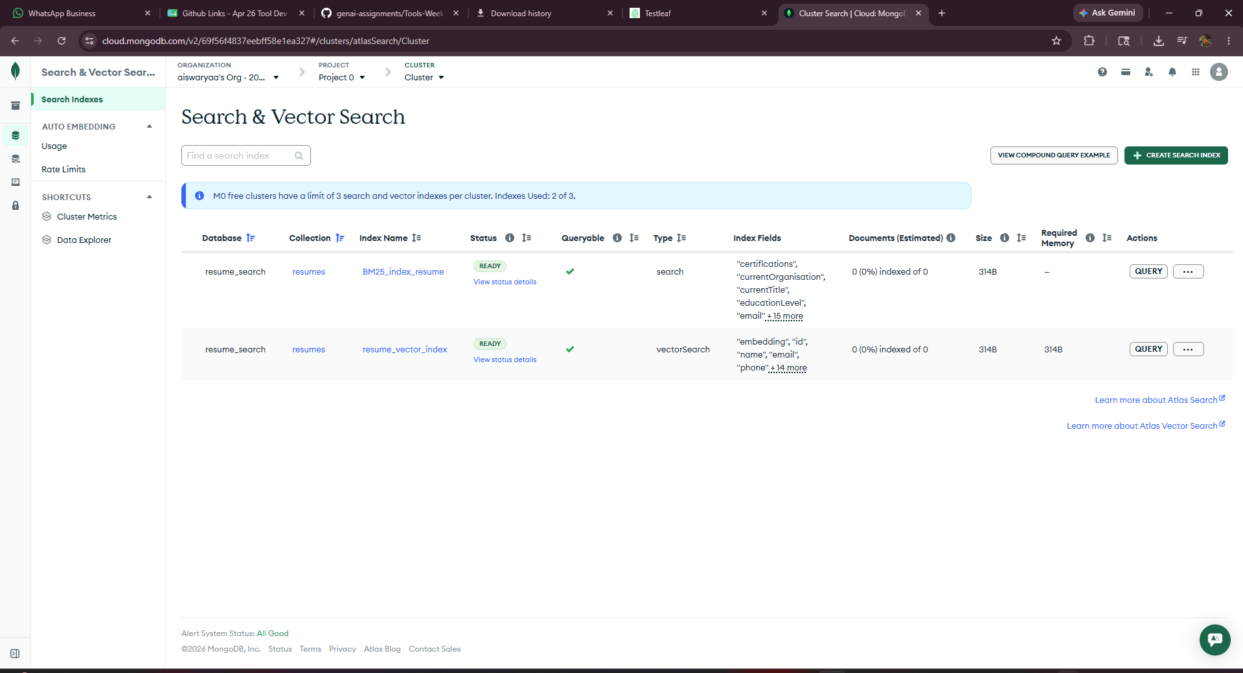

Langflow updated Ingestion Json -

- Select files
- Provide Mistral API keys
- Provide the right details about mongo db index and collections , cluster url
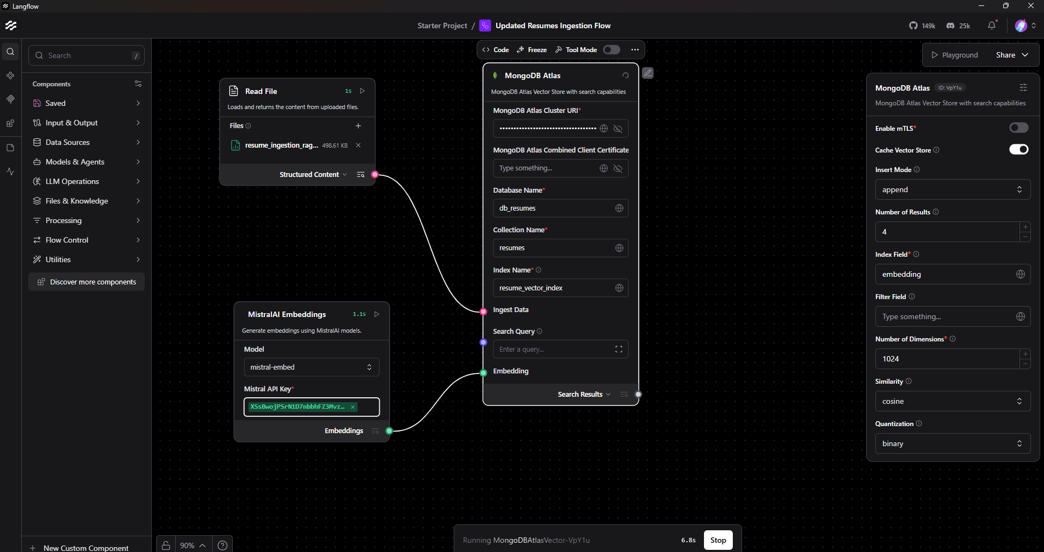

Execute the flow and documents gets uploaded in Mongo db by taking up these inputs in langflow.

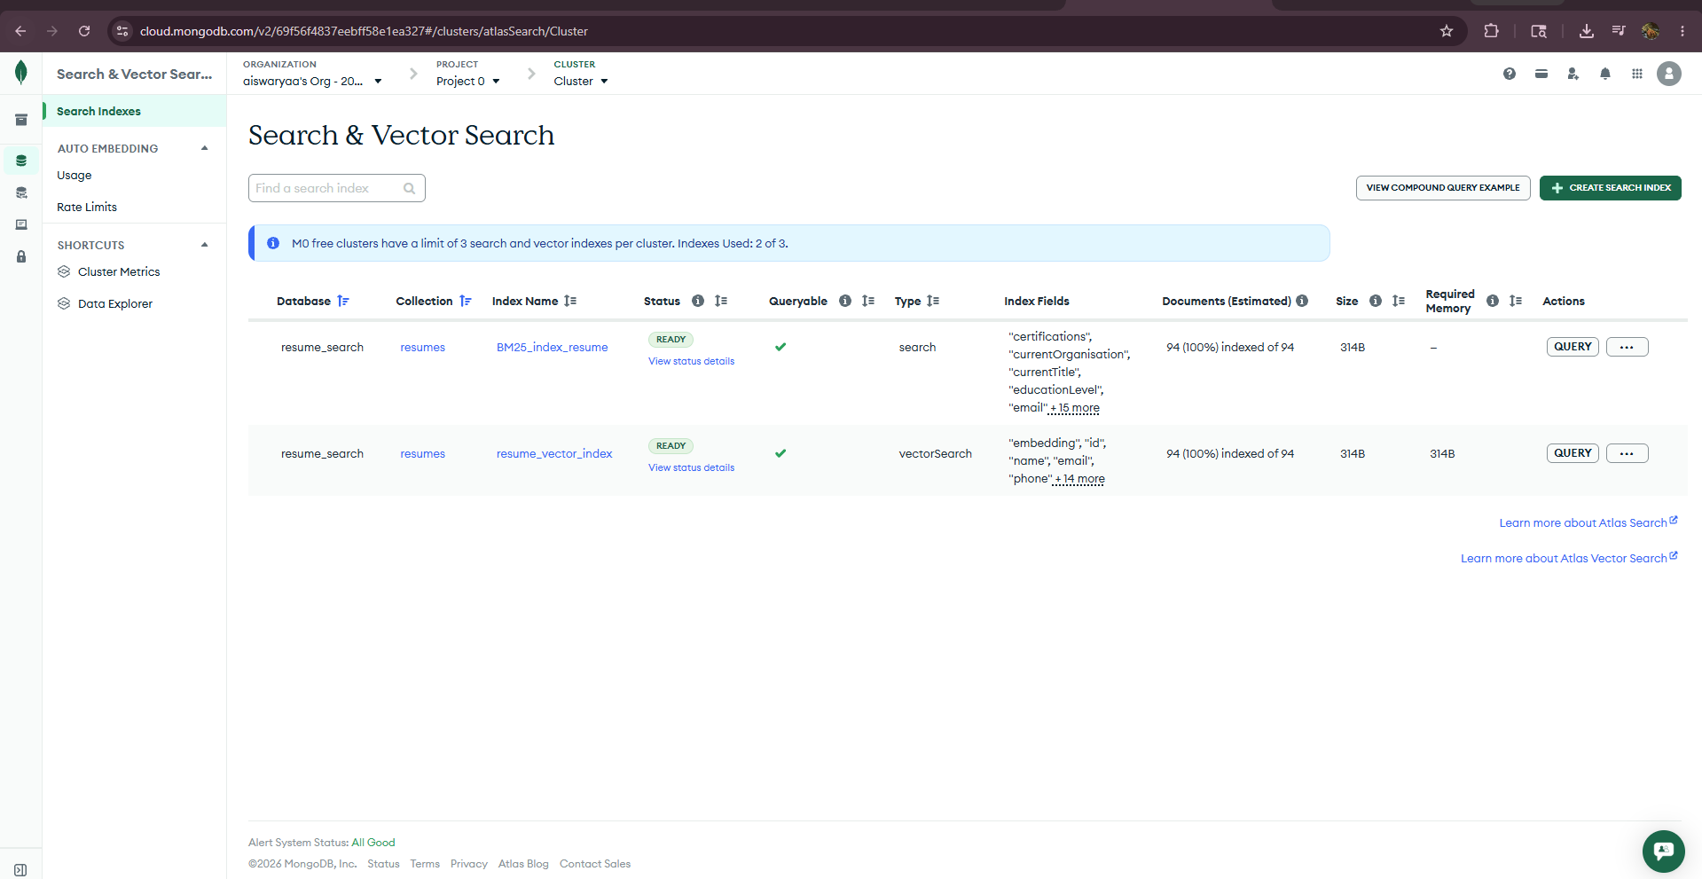

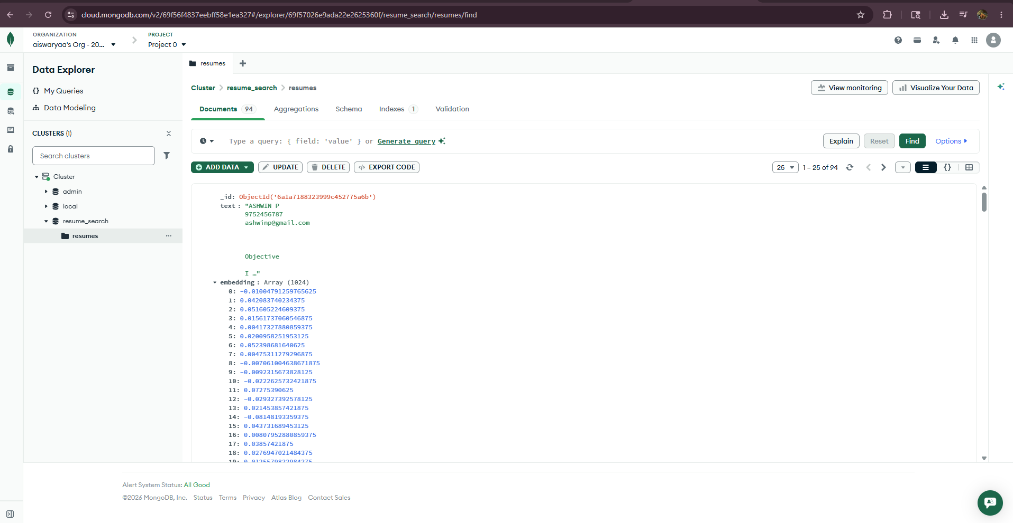

Documents available in mongo db
In VsCode run the command npm run dev
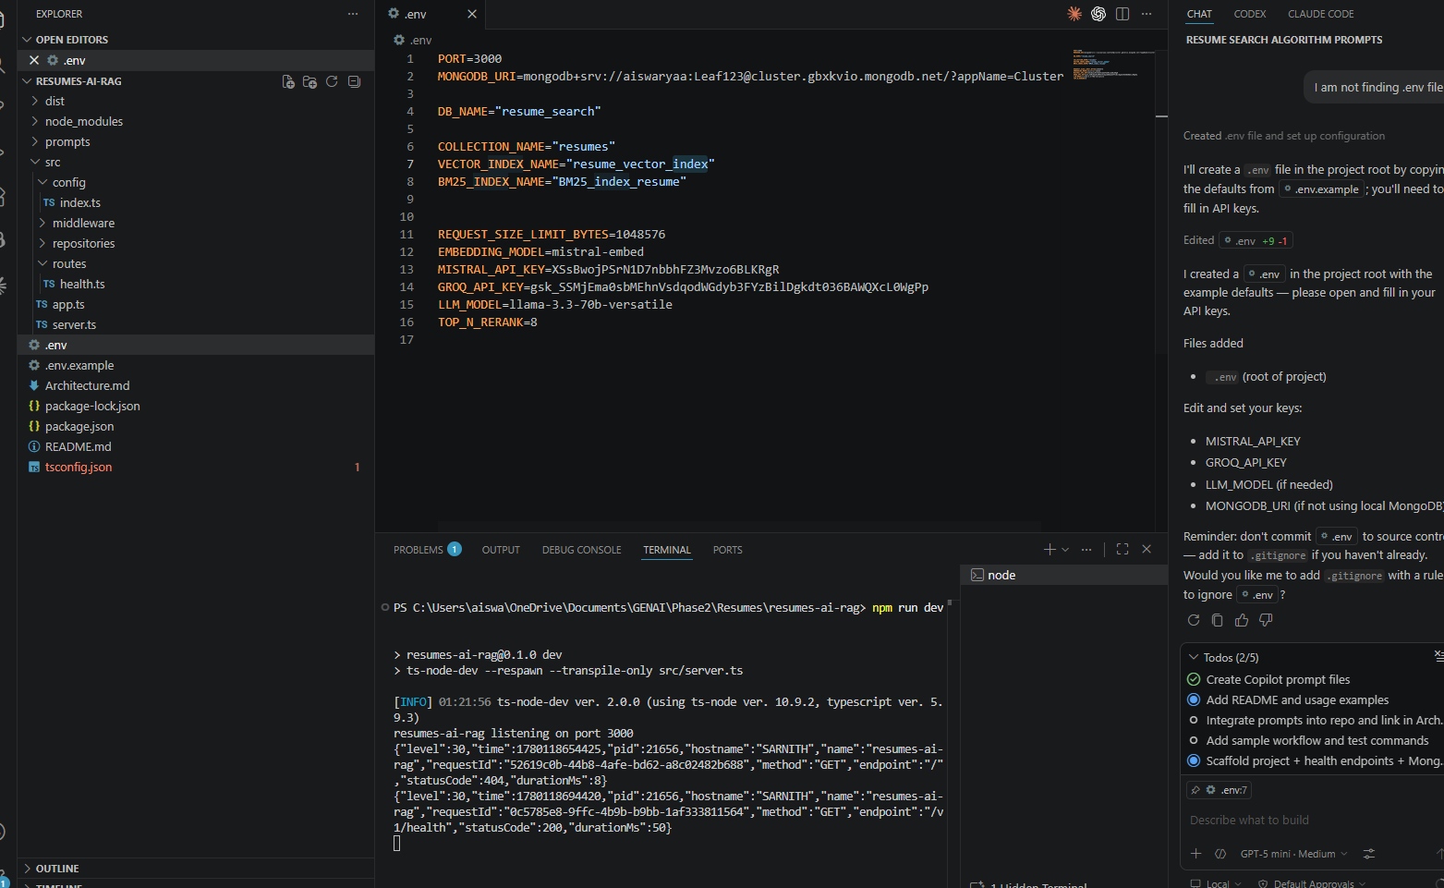

Postman health Check
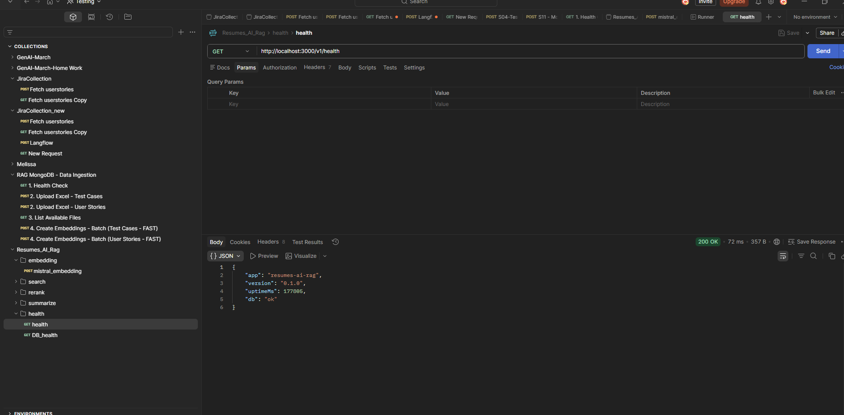

DB Health
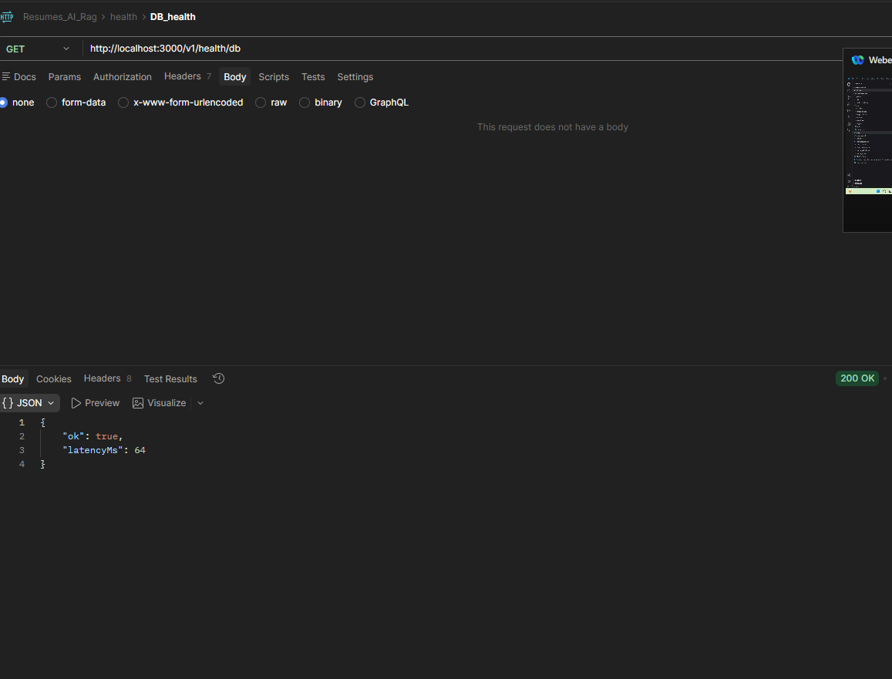

Vector Search API
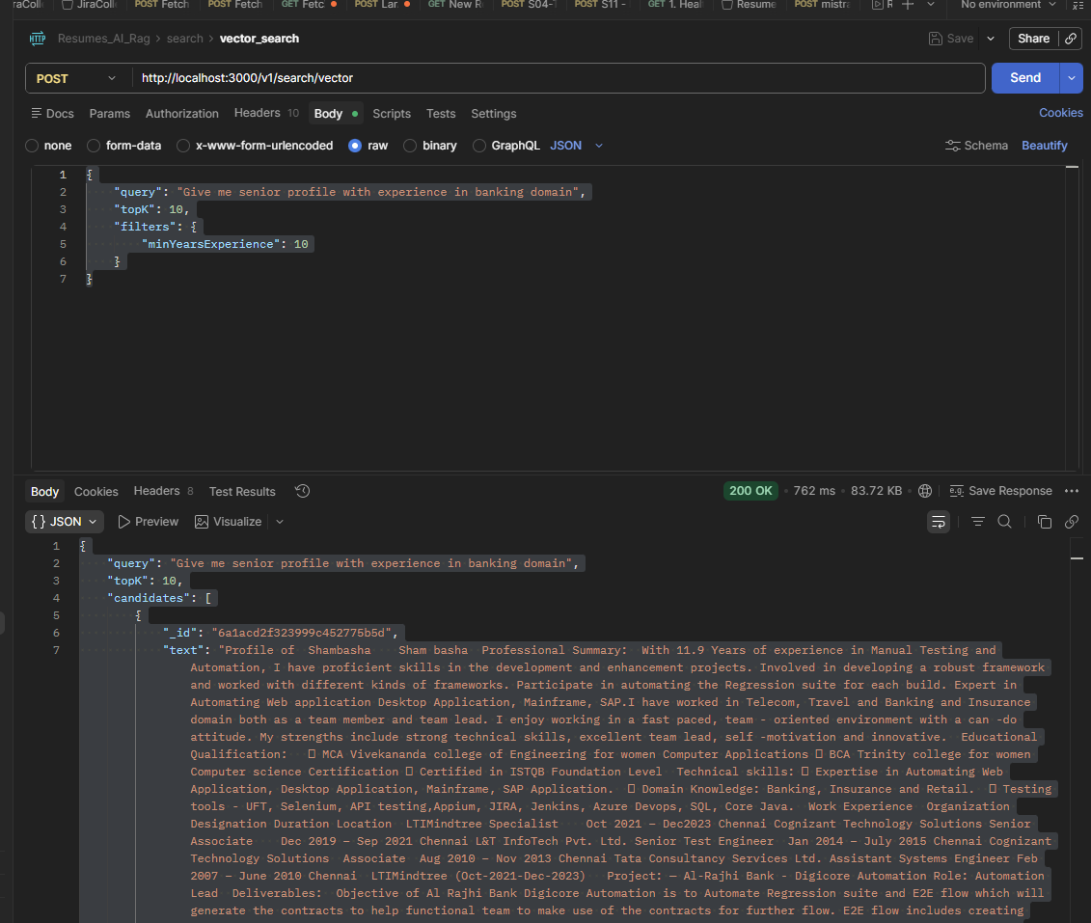
BM25 Search
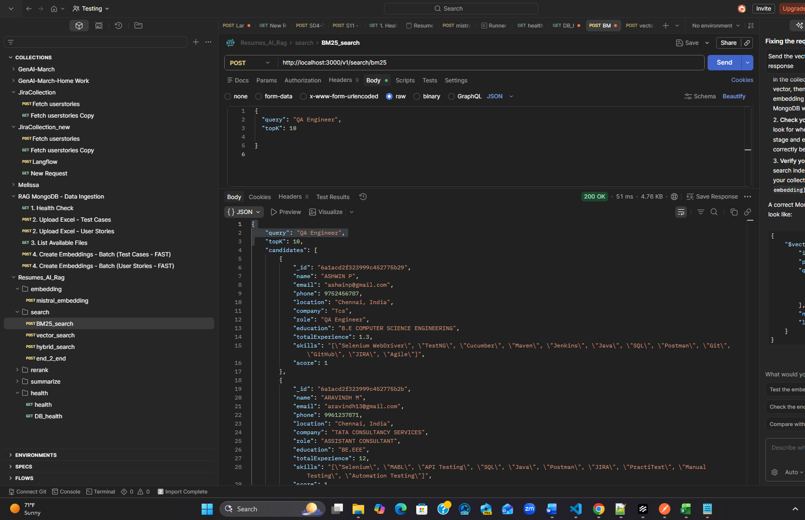

Hybrid Search :

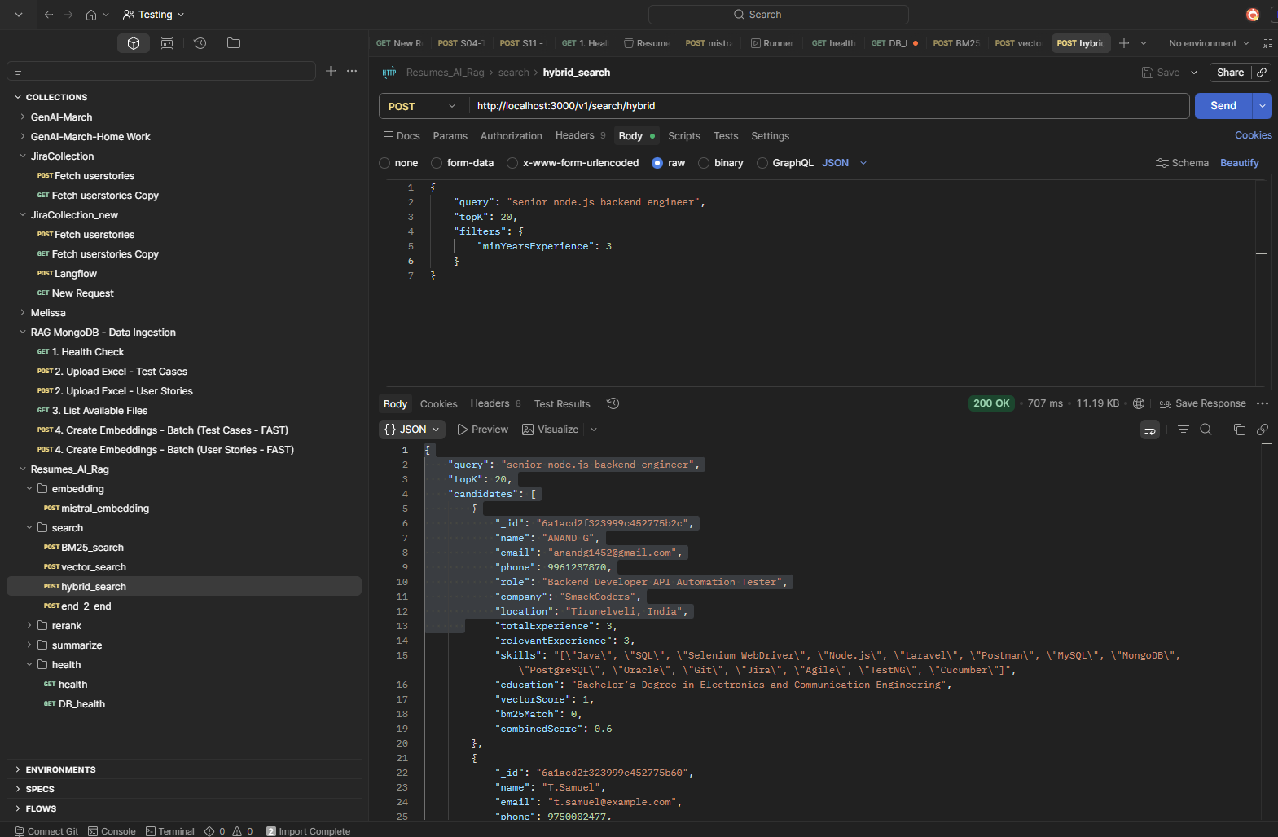

Rerank – Minimal :
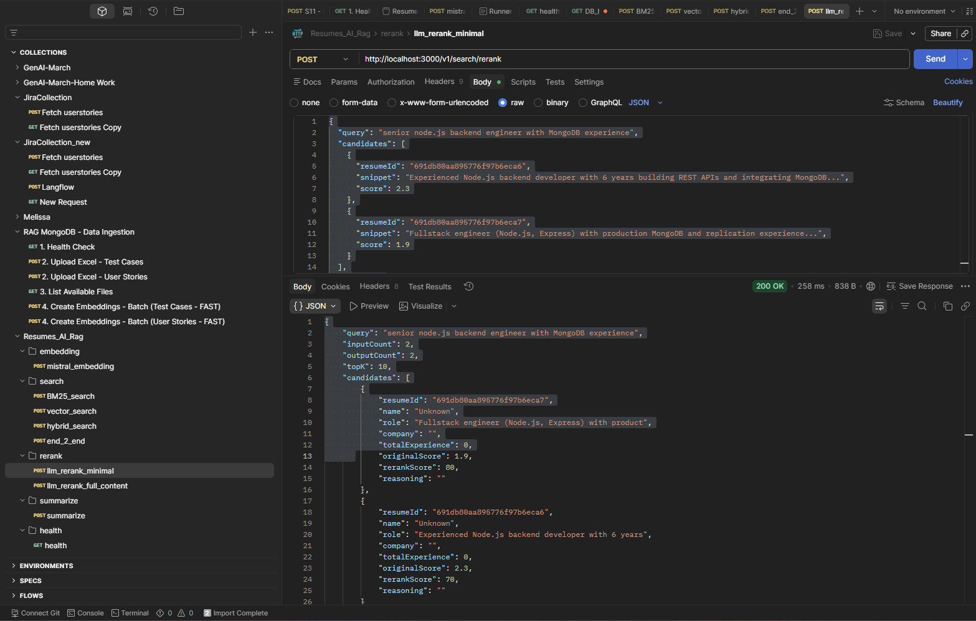
Rerank full content
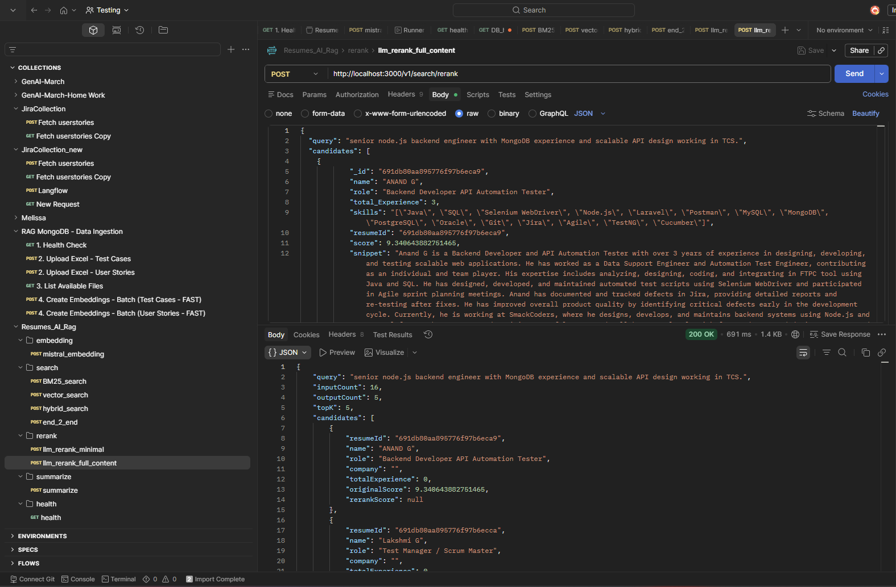

AI Summarize :
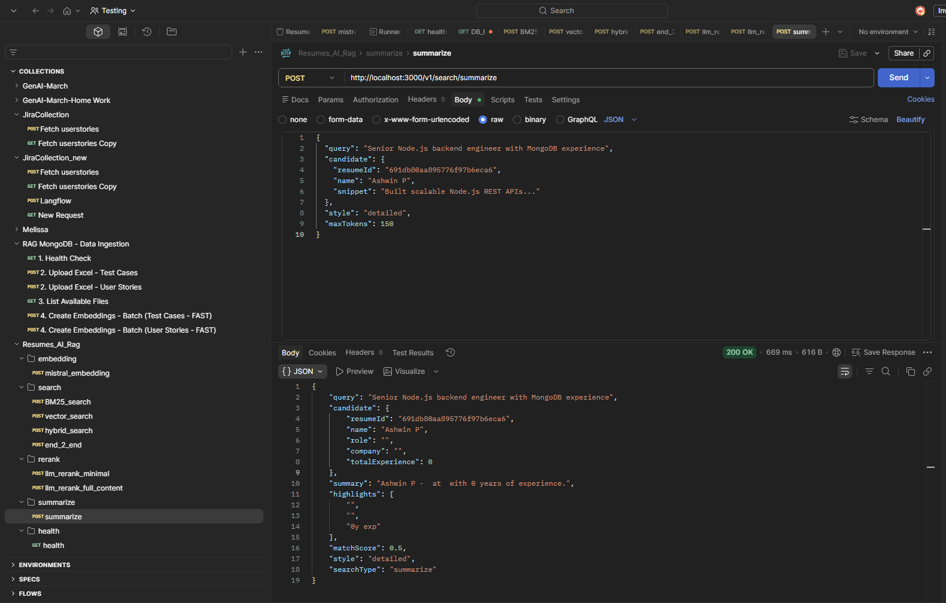
End To end Search – reranking
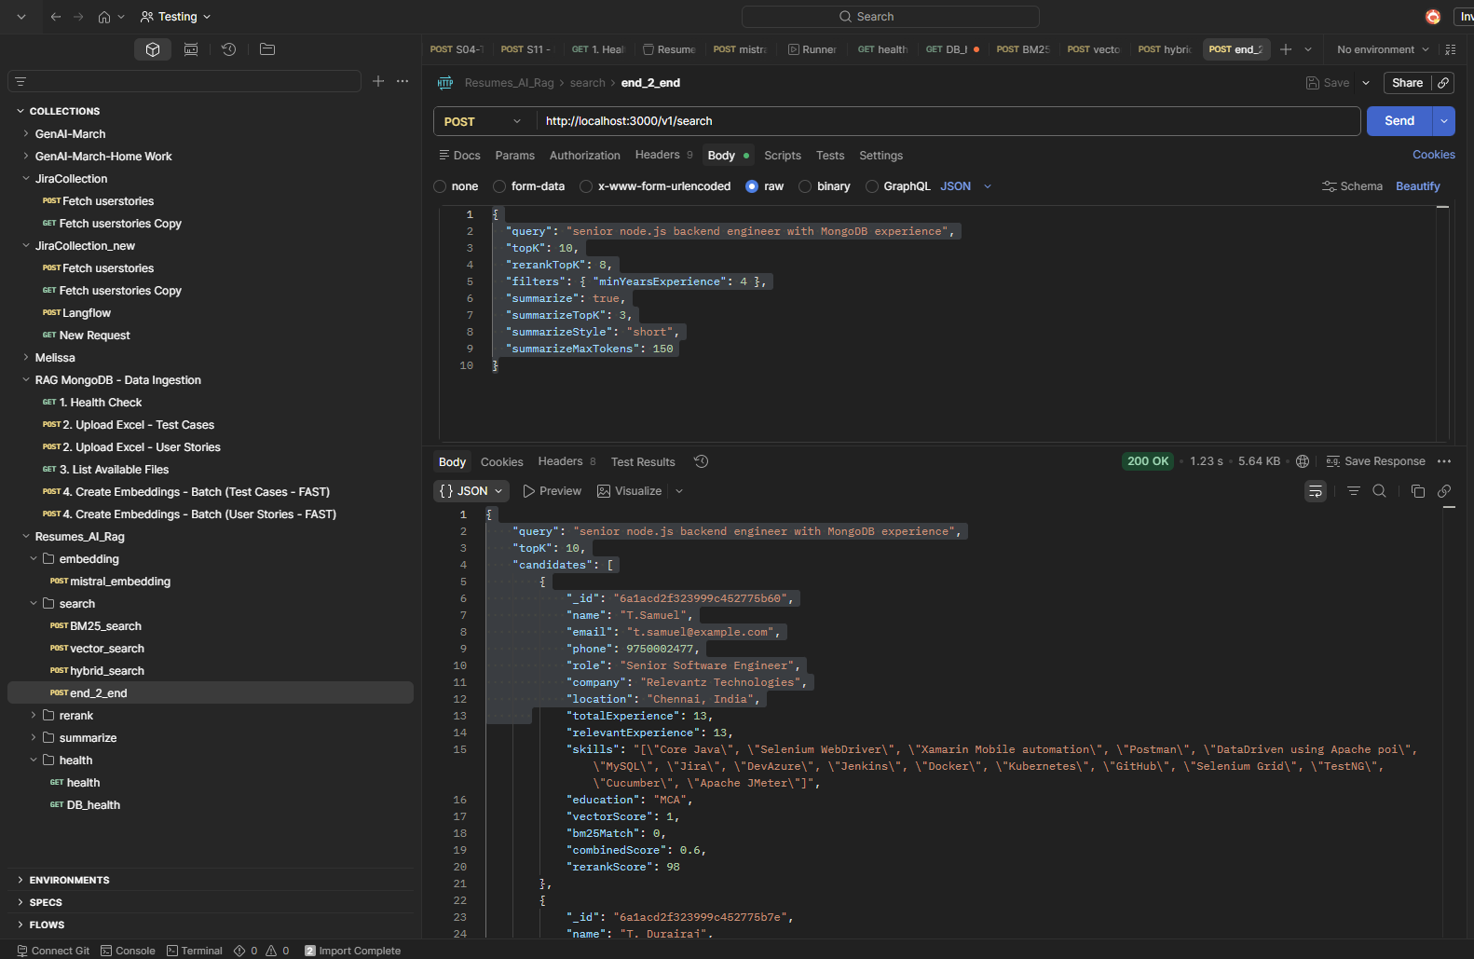

Ingestion Pipeline :
1)Place the architecture file ( Resume_Ingestion_Architecture_Phasewise.Md) into workspace
2) Provide prompt with architecture file in github implement phase by phase
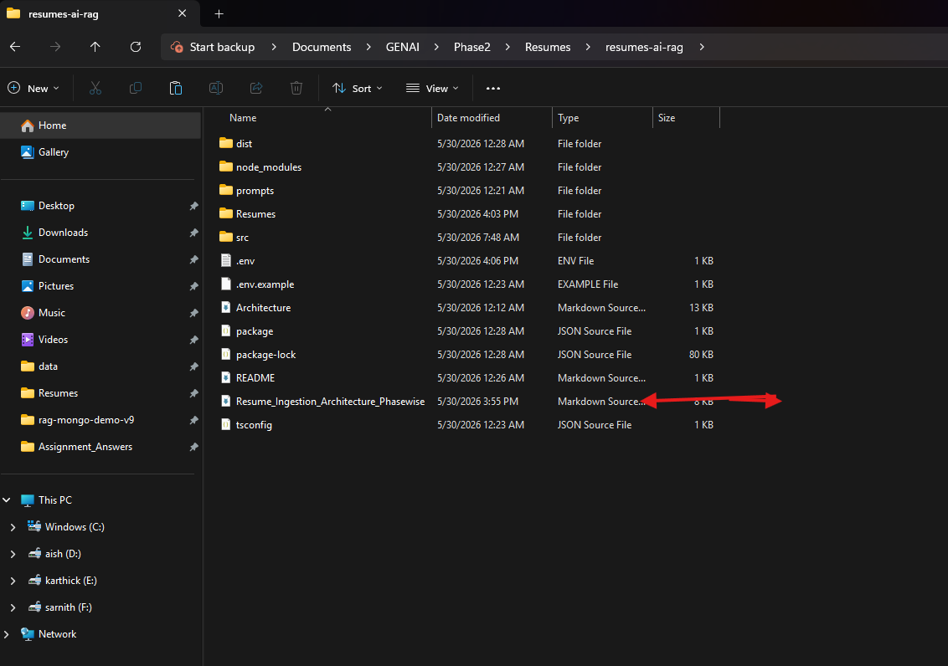
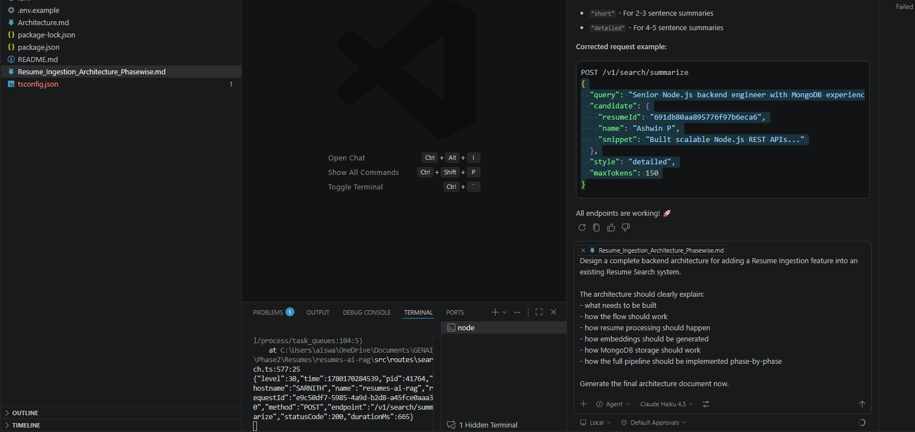
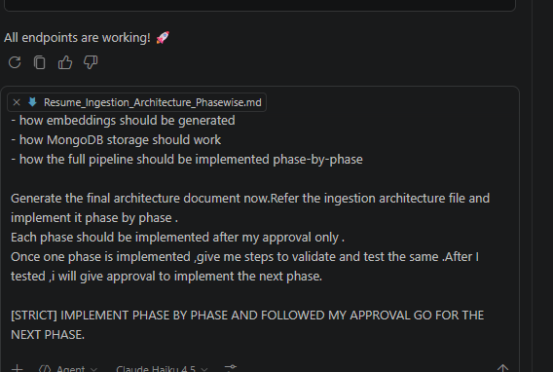
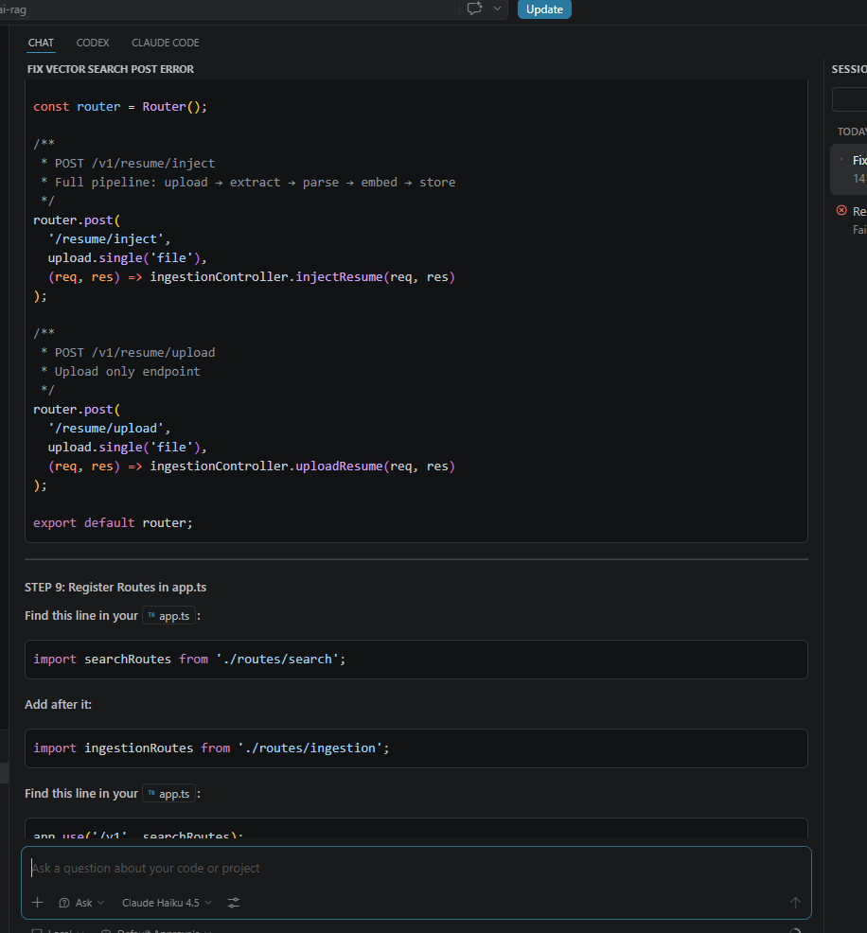
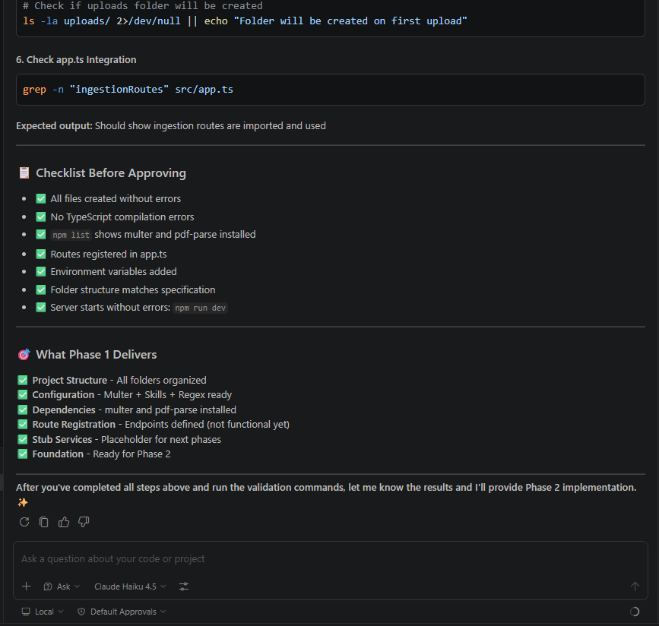
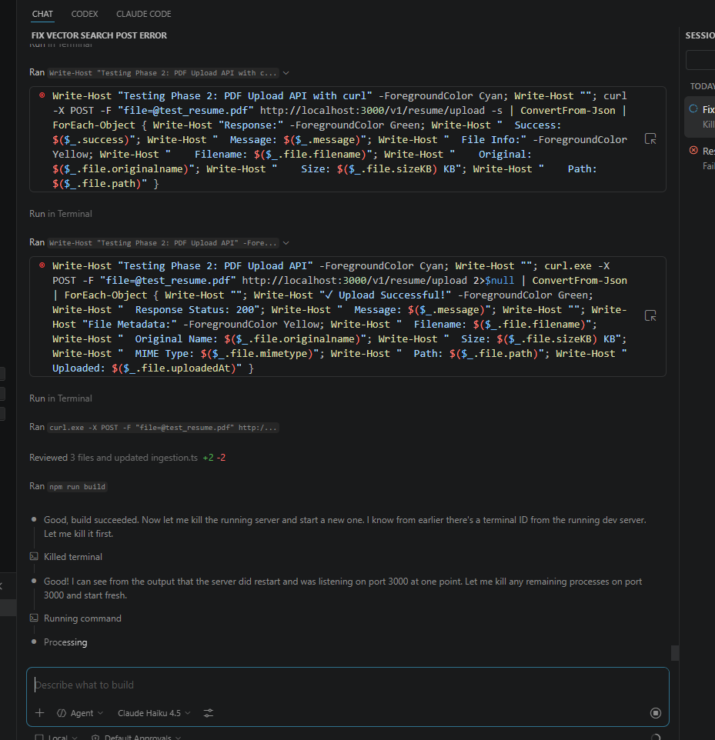
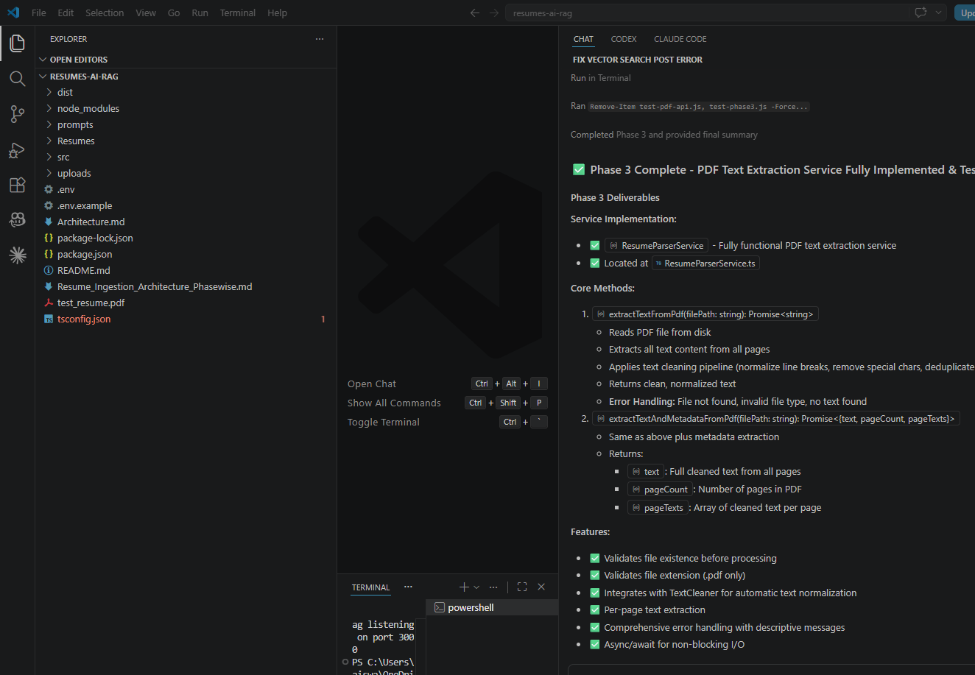
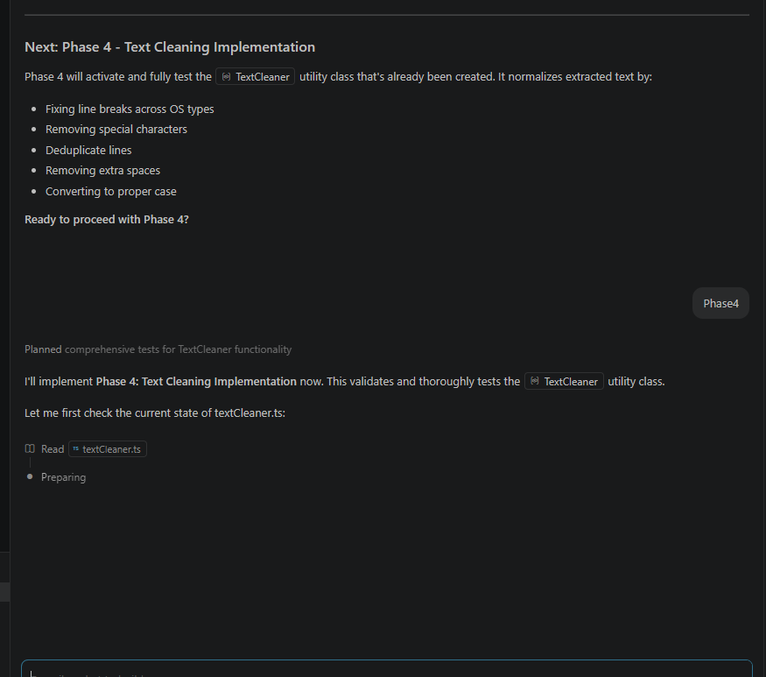
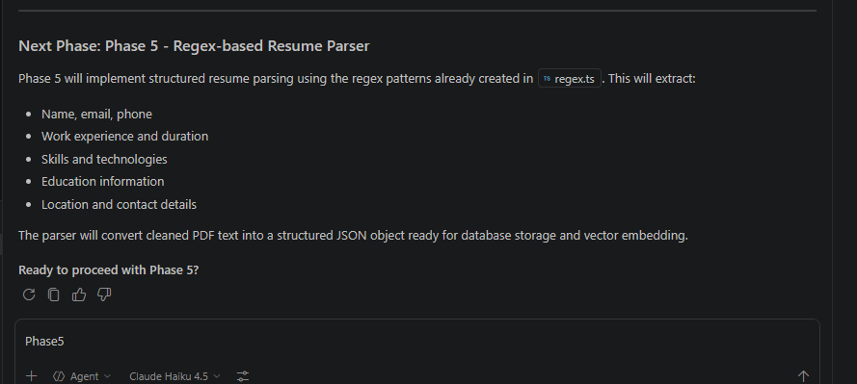
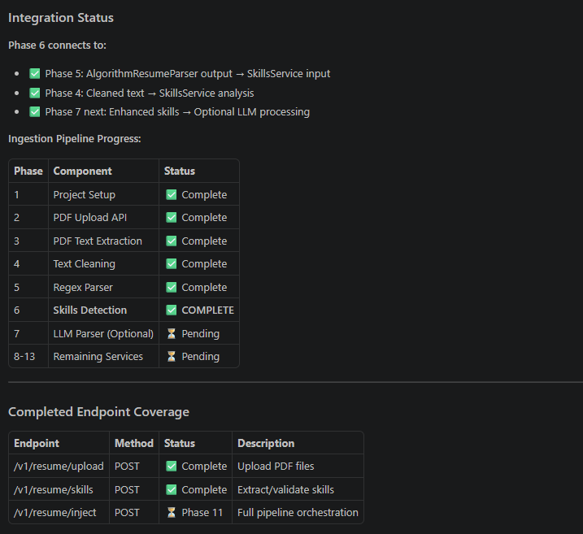
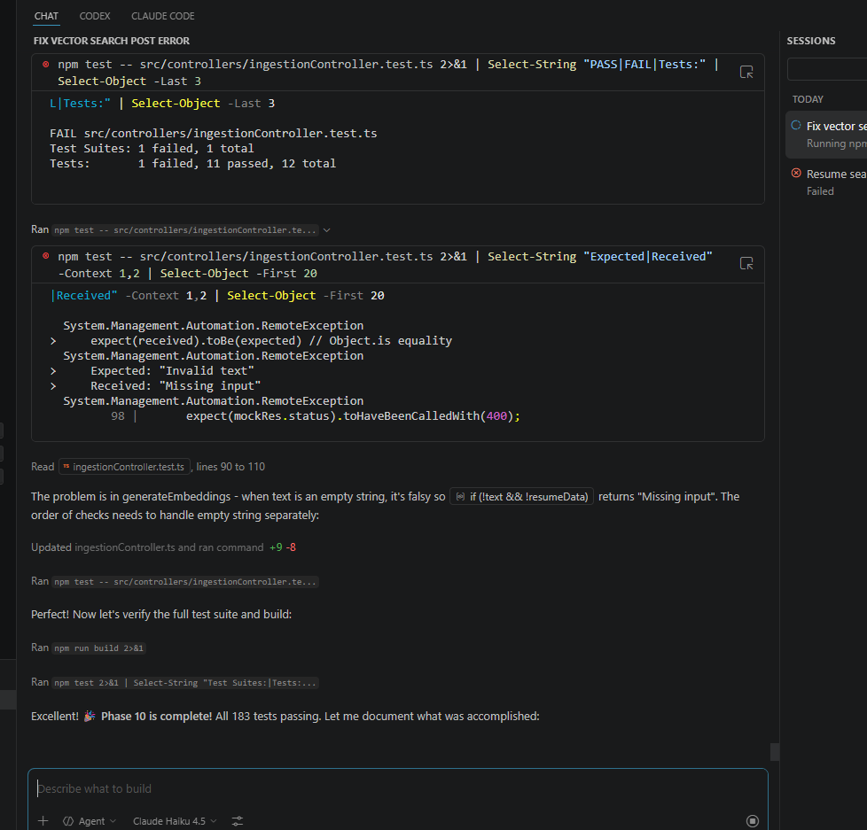

Batch Injestion Prompt Template
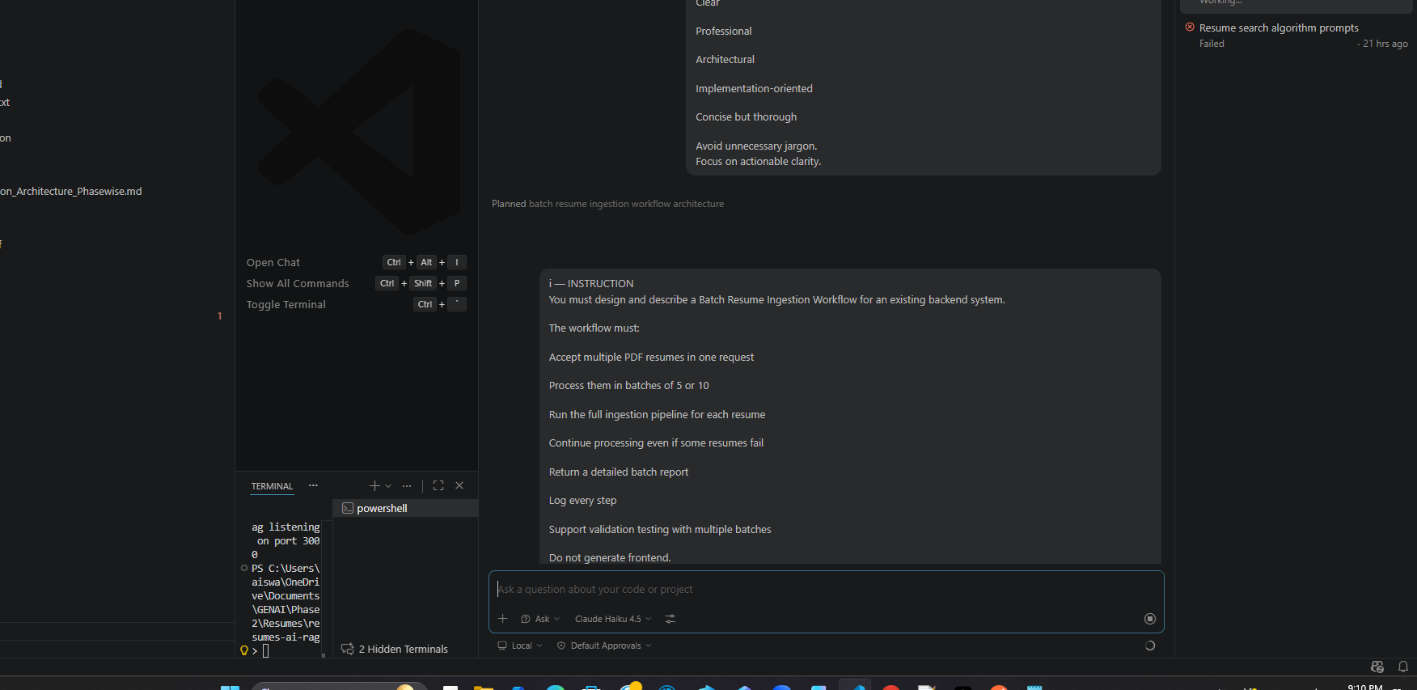
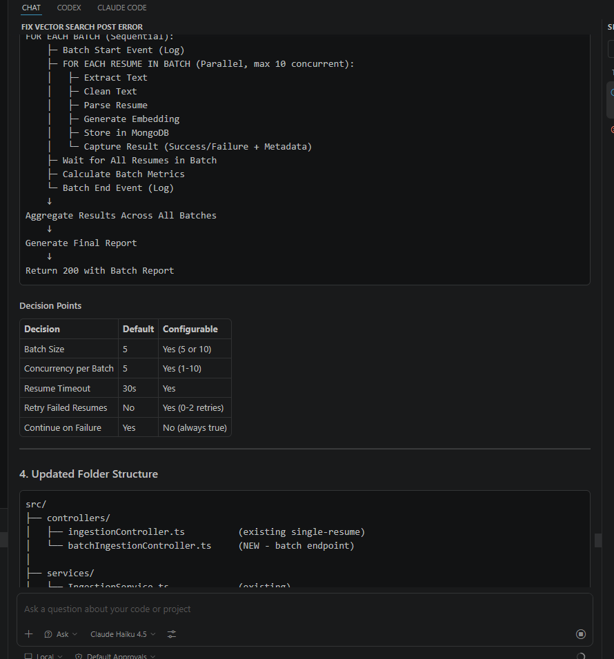
Batch Processing implementation with agent is completed
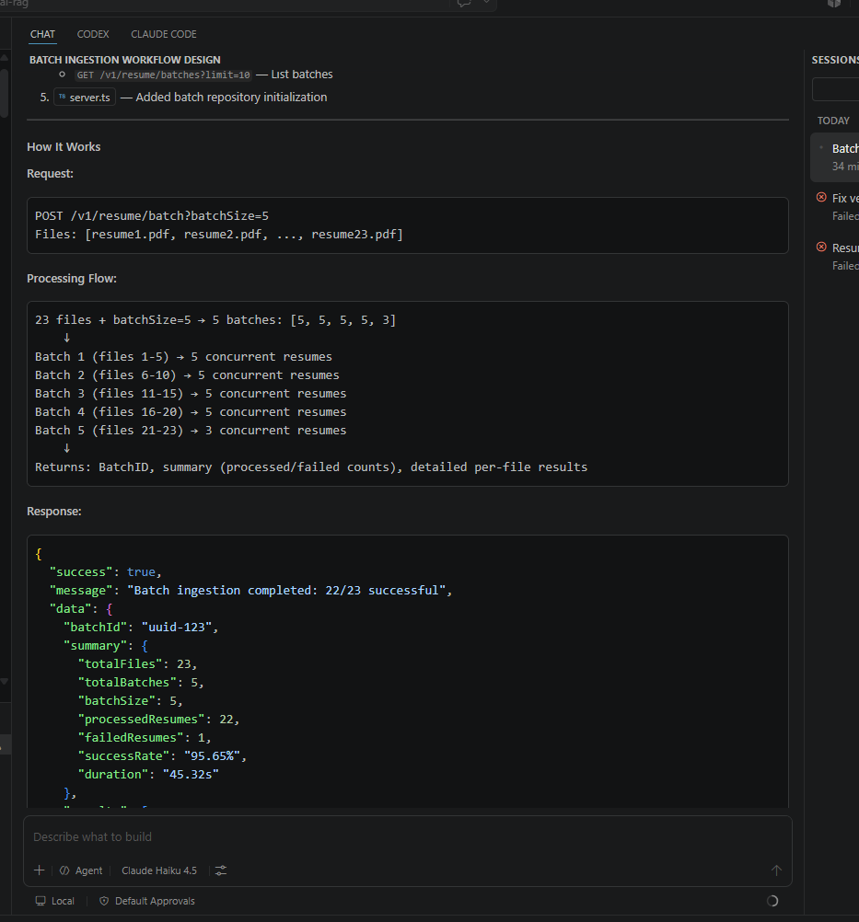
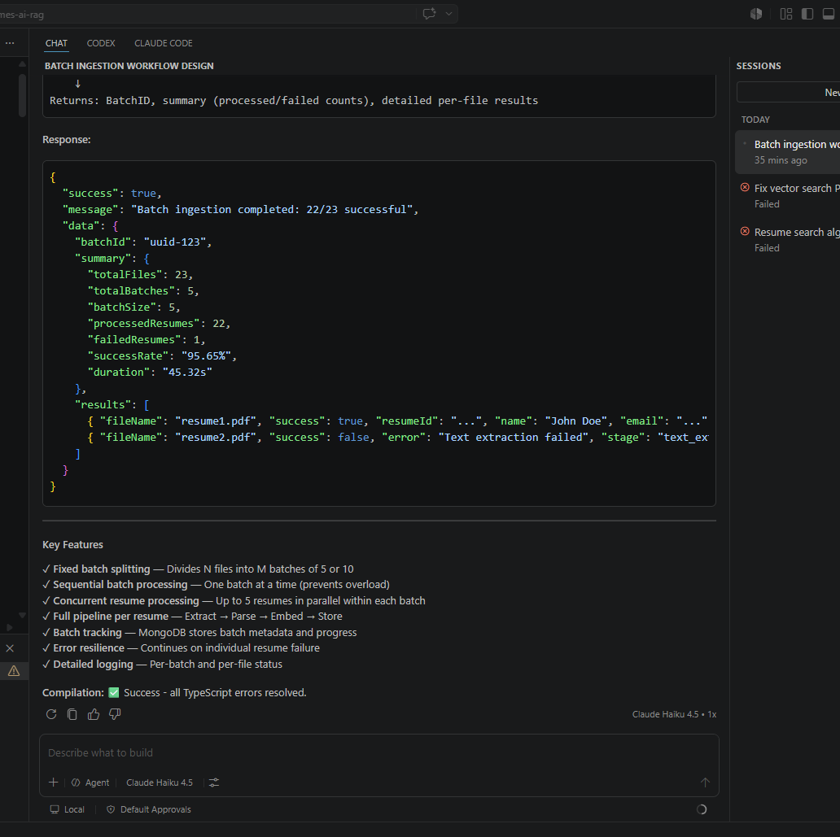
Resumes – folder (199 files ) placed under workspace
npm run batch – read .pdf files from Resumes folder and converted to text and -json stored in Mongo_db

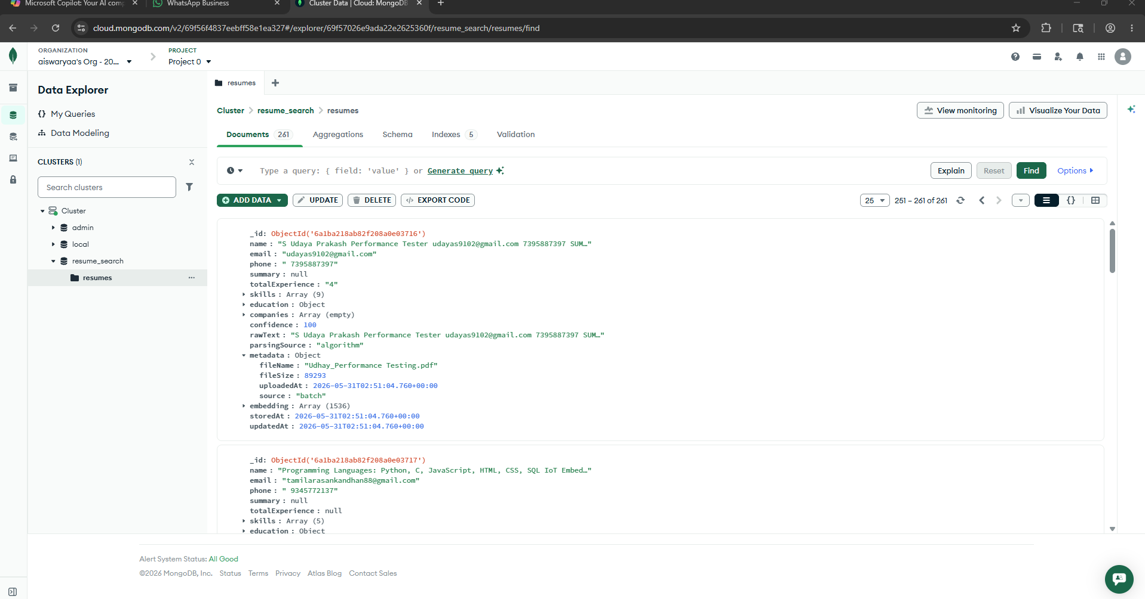
═══════════════════════════════════════════════════
✅ BATCH PROCESSING COMPLETED
═══════════════════════════════════════════════════

📊 SUMMARY:
Total Files: 180
Ingestion Batches: 2
✓ Processed: 167
✗ Failed: 13
Success Rate: 92.78%
Duration: 76.28s

📋 SUCCESS SAMPLES (first 10):
1. ✓ Abish - Marketing (1) (1).pdf
Name: Phone: 91 8668169115 Email: abzsh05@gmail.com Address: Native: Kanyakumari Working: Chennai DIGITAL MARKETING SPECIALIST SEO SOCIAL MEDIA STRATEGIST Abish SH PROFESSIONAL SUMMARY Digital Marketing Specialist with proven results in SEO and Ads campaigns across industries, from startups to large e-commerce brands. Skilled in building and leading teams, driving online visibility, generating leads, and delivering ROI-focused strategies. EDUCATION Bachelor of Engineering 2015-2019 PROFESSIONAL EXPERIENCE 1.SEO Manager Ludo Digitech Sep 2023 Present Managing SEO strategies, SMO, and paid ad campaigns (Google Ads Meta Ads). Client sourcing through personal networking and proposals. Handling end-to-end client projects: strategy, execution, and reporting. Website design and optimization in WordPress. Copywriting for campaigns and client websites. Key Clients: Legal Prime (Law associates SEO) Heutetrend (Corporate gifting Website) Raahat by Paritha (Fashion Social Media) Fashiyana Boutique (Fashion Social Media) RK Catering (Website) Depotfinol (Montenegro) Medcodbill (Czech Republic) 2. Digital Marketing Lead Trainer Izeon Innovative Pvt. Ltd. Jun 2022 Sep 2023 Led SEO, Google Ads, and Meta Ads campaigns. Designed and implemented social media strategies. Conducted Digital Marketing training for interns and students. Mentored new professionals in SEO and ad campaign management. 3. SEO Executive JKV Global Sourcing Solutions Sep 2019 Jun 2022 Specialized in link building outreach through backlink submissions. On-page optimization: internal linking, meta tags, schema markup, indexing. Performance monitoring using Google Analytics Search Console. Worked remotely for 1.5 years during the pandemic. TOOLS PLATFORMS SEO Tools: SEMrush, Ahrefs, Google Search Console Analytics Ads: Google Analytics, Google Ads, Meta Ads Manager CMS Design: WordPress, Basic HTML CSS Others: Social Media Management tools, Copywriting utilities INDUSTRIES SERVED Travel Law Clinics NGO E-commerce Sports Gym Fashion Boutiques Catering Corporate Gifting Bridal Interior Design Digital Marketing SKILLS EXPERTISE Search Engine Optimization (SEO): 95 Social Media Strategy (SMO): 95 Meta Ads Campaigns: 80 (CTR up to 6.5 for travel agency) Google Ads: 75 Client Handling: 80 WordPress: 70 Copywriting: 50 Cold Calling Lead Generation: 50 Team Leadership: 100
Email: abzsh05@gmail.com
ID: 6a1ba1d1ab82f208a0e03679
2. ✓ Abish - Marketing (1).pdf
Name: Phone: 91 8668169115 Email: abzsh05@gmail.com Address: Native: Kanyakumari Working: Chennai DIGITAL MARKETING SPECIALIST SEO SOCIAL MEDIA STRATEGIST Abish SH PROFESSIONAL SUMMARY Digital Marketing Specialist with proven results in SEO and Ads campaigns across industries, from startups to large e-commerce brands. Skilled in building and leading teams, driving online visibility, generating leads, and delivering ROI-focused strategies. EDUCATION Bachelor of Engineering 2015-2019 PROFESSIONAL EXPERIENCE 1.SEO Manager Ludo Digitech Sep 2023 Present Managing SEO strategies, SMO, and paid ad campaigns (Google Ads Meta Ads). Client sourcing through personal networking and proposals. Handling end-to-end client projects: strategy, execution, and reporting. Website design and optimization in WordPress. Copywriting for campaigns and client websites. Key Clients: Legal Prime (Law associates SEO) Heutetrend (Corporate gifting Website) Raahat by Paritha (Fashion Social Media) Fashiyana Boutique (Fashion Social Media) RK Catering (Website) Depotfinol (Montenegro) Medcodbill (Czech Republic) 2. Digital Marketing Lead Trainer Izeon Innovative Pvt. Ltd. Jun 2022 Sep 2023 Led SEO, Google Ads, and Meta Ads campaigns. Designed and implemented social media strategies. Conducted Digital Marketing training for interns and students. Mentored new professionals in SEO and ad campaign management. 3. SEO Executive JKV Global Sourcing Solutions Sep 2019 Jun 2022 Specialized in link building outreach through backlink submissions. On-page optimization: internal linking, meta tags, schema markup, indexing. Performance monitoring using Google Analytics Search Console. Worked remotely for 1.5 years during the pandemic. TOOLS PLATFORMS SEO Tools: SEMrush, Ahrefs, Google Search Console Analytics Ads: Google Analytics, Google Ads, Meta Ads Manager CMS Design: WordPress, Basic HTML CSS Others: Social Media Management tools, Copywriting utilities INDUSTRIES SERVED Travel Law Clinics NGO E-commerce Sports Gym Fashion Boutiques Catering Corporate Gifting Bridal Interior Design Digital Marketing SKILLS EXPERTISE Search Engine Optimization (SEO): 95 Social Media Strategy (SMO): 95 Meta Ads Campaigns: 80 (CTR up to 6.5 for travel agency) Google Ads: 75 Client Handling: 80 WordPress: 70 Copywriting: 50 Cold Calling Lead Generation: 50 Team Leadership: 100
Email: abzsh05@gmail.com
ID: 6a1ba1d1ab82f208a0e0367a
3. ✓ ABNER RESUME CVV (1).pdf
Name: J ABNER FERDINAND Marketing and Operations Enthusiast 8897210329OMR, Chennai www.linkedin.com in abner-ferdinand- abnerferdinand3@gmail.com EXECUTIVE SUMMARY An enthusiastic MBA graduate with a solid background in Marketing and Operations, I have a strong grasp of digital marketing principles, customer engagement strategies, and relationship management. I also understand customer-centric approaches, as well as logistics and supply chain processes. I am eager to learn, tackle business challenges, and support organizational growth through impactful marketing initiatives and streamlined operational practices. WORK EXPERIENCE METAL SCOPE PVT LIMITED Operation Assistant internship, Pondicherry. SKILL Problem Solving ZOHO CRM MS OFFICE EDUCATION MBA, (Marketing and Operations)- St. Joseph s College of Engineering, 2024-NOW Currently pursuing with the CGPA of 7.52 BBA (HRM), Little Flower Intermediate and Degree College,Hyderabad 2021- 2024 CGPA was 8.14 out of 10 Intermediate-David Memorial Intermediate and Degree College,Hyderabad2022- 2023 Commerce with Accountancy, scored 67 Completed a one-month internship gaining hands-on experience in inventory management, production floor operations, and machinery maintenance. Strengthened understanding of the metal fabrication industry and the role of accurate inventory and production management in ensuring operational efficiency. WORKSHOPS, CERTIFICATIONS Certification in International marketing Completed a Digital Marketing Workshop and Certification from Stellar Academy Certification in BI Accuracy software for logistics and supply chain measurements Certification: Zoho CRM Fundamentals Certification: Supply Chain Management Fundamentals Certification: Semrush SEO Fundamentals IBM Certification: Customer Engagement Problem Solving and Process Control Skills IBM Certification: Customer Engagement Communication and Personality Dynamics Skills English, Hindi, Tamil, Telugu (Fluent) LANGUAGES Transportation Logistics Basics Digital Marketing Bi - Accuracy software
Email: abnerferdinand3@gmail.com
ID: 6a1ba1d1ab82f208a0e0367b
4. ✓ ABNER RESUME CVV.pdf
Name: J ABNER FERDINAND Marketing and Operations Enthusiast 8897210329OMR, Chennai www.linkedin.com in abner-ferdinand- abnerferdinand3@gmail.com EXECUTIVE SUMMARY An enthusiastic MBA graduate with a solid background in Marketing and Operations, I have a strong grasp of digital marketing principles, customer engagement strategies, and relationship management. I also understand customer-centric approaches, as well as logistics and supply chain processes. I am eager to learn, tackle business challenges, and support organizational growth through impactful marketing initiatives and streamlined operational practices. WORK EXPERIENCE METAL SCOPE PVT LIMITED Operation Assistant internship, Pondicherry. SKILL Problem Solving ZOHO CRM MS OFFICE EDUCATION MBA, (Marketing and Operations)- St. Joseph s College of Engineering, 2024-NOW Currently pursuing with the CGPA of 7.52 BBA (HRM), Little Flower Intermediate and Degree College,Hyderabad 2021- 2024 CGPA was 8.14 out of 10 Intermediate-David Memorial Intermediate and Degree College,Hyderabad2022- 2023 Commerce with Accountancy, scored 67 Completed a one-month internship gaining hands-on experience in inventory management, production floor operations, and machinery maintenance. Strengthened understanding of the metal fabrication industry and the role of accurate inventory and production management in ensuring operational efficiency. WORKSHOPS, CERTIFICATIONS Certification in International marketing Completed a Digital Marketing Workshop and Certification from Stellar Academy Certification in BI Accuracy software for logistics and supply chain measurements Certification: Zoho CRM Fundamentals Certification: Supply Chain Management Fundamentals Certification: Semrush SEO Fundamentals IBM Certification: Customer Engagement Problem Solving and Process Control Skills IBM Certification: Customer Engagement Communication and Personality Dynamics Skills English, Hindi, Tamil, Telugu (Fluent) LANGUAGES Transportation Logistics Basics Digital Marketing Bi - Accuracy software
Email: abnerferdinand3@gmail.com
ID: 6a1ba1d1ab82f208a0e0367c
5. ✓ Anish_Kumar_S_Resume 1 (1).pdf
Name: ANISH KUMAR S Quality Assurance Analyst anishkumarsankar2023@gmail.com 91 93633 84114 Chennai TN PROFESSIONAL SUMMARY 4 years of industry experience in the area of Software Testing (Manual, Web, Mobile and API) with a solid understanding of Test Planning, Test Design, Test Execution and Defect Reporting Tracking Expertise in Understanding and Analyzing Test Requirements, Tracking changes and maintenance of Test Requirements Strong Experience in Automating Web Application Testing using Selenium WebDriver with Cucumber framework Strong Experience in Java Programming, Junit and TestNG Well versed with Handling Elements in Selenium WebDriver Strong Experience writing Test cases using Element locators, WebDriver methods and Java programming features Strong Experience in handling tools like GITHUB Executing Selenium Test Cases and Reporting defects Experience in developing test cases based on requirements in JIRA Experience in POSTMAN Tool and Rest Assured for API Integration Good experience using Appium for iOS and Android applications. Experience in executing queries using MYSQL Good written, communication, interpersonal skills, proven team player with an analytical mind bent to problem solving and delivering solutions WORK HISTORY Quality Assurance Analyst Gembrill Technologies Chennai 01 2022 - 10 2025 Client: Koncert Sales Engagement Platform Domain: Customer Relationship Management Description: Koncert is a Sales Engagement Platform which acts as a standard interface between the clients and all the sales representatives and is used to increase sales performance through Calls, Emails and other Social platforms. Client: Koncert Cadence Domain: Telecom and CRM Description: Cadence is an add on product of Koncert which is used for continuous follow-up and tracking tool to generate business call, email, text, social media and other touches. Responsibilities: Scripting using Java programming. Good at finding X-path locators. Implemented automation using Selenium WebDriver and Maven. Developed and executed the automation test scripts using the BDD framework. Developing BDD tests using Cucumber by writing feature files and step definitions. Execute test cases manually to identify bugs, and ensure the application meets functional and business requirements. Developing reusable functional components in the framework. Maintained locators using the Page Object Model. Updated framework functions when needed. Involved in pushing, pulling, and merging the source code from GitHub. Reviewing the test reports and preparing the test summary report. Preparation of test scenarios, test cases, test execution and test results. Used Postman API to get convenient, visual display of query result Tested changes to user interface, application functionality and database access as required by the organizations Skilled in Appium for Mobile Automation Testing, including configuring the Appium test environment, creating MobileDriver classes with desired capabilities, and identifying mobile elements using Appium Inspector Reporting any defects or Observation on day-to-day basis Attending Agile meetings on assigned projects Understanding the Business Requirement Specification. Designing Test Cases, Execution of the test cases and reporting the bugs. Conducted Functional testing with Valid and Invalid inputs for positive and negative testing. Executing Tests and analyzing results as per client requirements. Detecting the bugs and classifying them based on the severity and reporting. Being part of all requirement gatherings and decisions to understand and deliver thoughts. Creating Test scenarios and Collecting Test Data. Tracking Defects and Select Test cases for Regression Testing. EDUCA TION Easwari Engineering College Chennai 2021 Bachelor of Engineering TECHNICAL SKILLS Programming Language: Core Java Automation Tool: Selenium Webdriver, RestAssured, Appium API Tool: Postman Version Control Tool: GIT Build Management Tool: Maven Frameworks: TestNG,JUnit, POM,Data Driven and BDD Defect Management Tool: Jira HR J 2e21286f-31a7-41c1-a59f-e81 0c996b575
Email: anishkumarsankar2023@gmail.com
ID: 6a1ba1d1ab82f208a0e0367d
6. ✓ Anish_Kumar_S_Resume 1.pdf
Name: ANISH KUMAR S Quality Assurance Analyst anishkumarsankar2023@gmail.com 91 93633 84114 Chennai TN PROFESSIONAL SUMMARY 4 years of industry experience in the area of Software Testing (Manual, Web, Mobile and API) with a solid understanding of Test Planning, Test Design, Test Execution and Defect Reporting Tracking Expertise in Understanding and Analyzing Test Requirements, Tracking changes and maintenance of Test Requirements Strong Experience in Automating Web Application Testing using Selenium WebDriver with Cucumber framework Strong Experience in Java Programming, Junit and TestNG Well versed with Handling Elements in Selenium WebDriver Strong Experience writing Test cases using Element locators, WebDriver methods and Java programming features Strong Experience in handling tools like GITHUB Executing Selenium Test Cases and Reporting defects Experience in developing test cases based on requirements in JIRA Experience in POSTMAN Tool and Rest Assured for API Integration Good experience using Appium for iOS and Android applications. Experience in executing queries using MYSQL Good written, communication, interpersonal skills, proven team player with an analytical mind bent to problem solving and delivering solutions WORK HISTORY Quality Assurance Analyst Gembrill Technologies Chennai 01 2022 - 10 2025 Client: Koncert Sales Engagement Platform Domain: Customer Relationship Management Description: Koncert is a Sales Engagement Platform which acts as a standard interface between the clients and all the sales representatives and is used to increase sales performance through Calls, Emails and other Social platforms. Client: Koncert Cadence Domain: Telecom and CRM Description: Cadence is an add on product of Koncert which is used for continuous follow-up and tracking tool to generate business call, email, text, social media and other touches. Responsibilities: Scripting using Java programming. Good at finding X-path locators. Implemented automation using Selenium WebDriver and Maven. Developed and executed the automation test scripts using the BDD framework. Developing BDD tests using Cucumber by writing feature files and step definitions. Execute test cases manually to identify bugs, and ensure the application meets functional and business requirements. Developing reusable functional components in the framework. Maintained locators using the Page Object Model. Updated framework functions when needed. Involved in pushing, pulling, and merging the source code from GitHub. Reviewing the test reports and preparing the test summary report. Preparation of test scenarios, test cases, test execution and test results. Used Postman API to get convenient, visual display of query result Tested changes to user interface, application functionality and database access as required by the organizations Skilled in Appium for Mobile Automation Testing, including configuring the Appium test environment, creating MobileDriver classes with desired capabilities, and identifying mobile elements using Appium Inspector Reporting any defects or Observation on day-to-day basis Attending Agile meetings on assigned projects Understanding the Business Requirement Specification. Designing Test Cases, Execution of the test cases and reporting the bugs. Conducted Functional testing with Valid and Invalid inputs for positive and negative testing. Executing Tests and analyzing results as per client requirements. Detecting the bugs and classifying them based on the severity and reporting. Being part of all requirement gatherings and decisions to understand and deliver thoughts. Creating Test scenarios and Collecting Test Data. Tracking Defects and Select Test cases for Regression Testing. EDUCA TION Easwari Engineering College Chennai 2021 Bachelor of Engineering TECHNICAL SKILLS Programming Language: Core Java Automation Tool: Selenium Webdriver, RestAssured, Appium API Tool: Postman Version Control Tool: GIT Build Management Tool: Maven Frameworks: TestNG,JUnit, POM,Data Driven and BDD Defect Management Tool: Jira HR J 2e21286f-31a7-41c1-a59f-e81 0c996b575
Email: anishkumarsankar2023@gmail.com
ID: 6a1ba1d3ab82f208a0e03682
7. ✓ Arishraj Resume (1).pdf
Name: SUMMARY Languages: English, Tamil Certifications: Python, MS Word Excel Foundation Awards Activities: Actively participated in AIMA (All India Management Association) management events and business competitions, enhancing leadership and strategic thinking skills. Interests: Music, Books, Self Development Jun 2021 May 2024Bachelor of Business Administration (BBA) Hindustan College Of Arts Science Aug 2024 PresentMaster of Business Administration (MBA) Hindustan Institute of Technology Science, Chennai Major in HR Finance June 2025 - July 2025Mani Power Tools, Chennai Assisted in managing day-to-day financial operations, including invoice processing, expense tracking, and account reconciliation. Supported the preparation of financial statements and maintained accurate records in compliance with company policies. Collaborated with the accounts team to monitor cash flow and budget utilization. Utilized MS Excel for financial data analysis and report generation to support management decisions. Gained practical exposure to tax filing, payroll coordination, and vendor payment processes. Results-driven MBA graduate specializing in Human Resources and Finance, passionate about leveraging analytical, organizational, and interpersonal skills to drive business success. Proficient in Excel and strategic planning with hands-on experience in data analysis, process improvement, and team coordination. Adept at problem-solving, time management, and fostering collaboration across departments to achieve measurable results. ARISHRAJ T Chennai rajarish940@gmail.com LinkedIn www.linkedin.com in arish-raj MBA GRADUATE HR FINANCE TECHNICAL SKILLS INTERNSHIP EXPERIENCE EDUCATION ADDITIONAL INFORMATION Tools: MS Excel, Word, PowerPoint Areas of Knowledge: Payroll Management, Financial Reporting, Employee Engagement, Data Visualization Soft Skills: Leadership, Active Listening, Strategic Thinking, Communication Finance Admin Intern
Email: rajarish940@gmail.com
ID: 6a1ba1d3ab82f208a0e0367e
8. ✓ Arishraj Resume.pdf
Name: SUMMARY Languages: English, Tamil Certifications: Python, MS Word Excel Foundation Awards Activities: Actively participated in AIMA (All India Management Association) management events and business competitions, enhancing leadership and strategic thinking skills. Interests: Music, Books, Self Development Jun 2021 May 2024Bachelor of Business Administration (BBA) Hindustan College Of Arts Science Aug 2024 PresentMaster of Business Administration (MBA) Hindustan Institute of Technology Science, Chennai Major in HR Finance June 2025 - July 2025Mani Power Tools, Chennai Assisted in managing day-to-day financial operations, including invoice processing, expense tracking, and account reconciliation. Supported the preparation of financial statements and maintained accurate records in compliance with company policies. Collaborated with the accounts team to monitor cash flow and budget utilization. Utilized MS Excel for financial data analysis and report generation to support management decisions. Gained practical exposure to tax filing, payroll coordination, and vendor payment processes. Results-driven MBA graduate specializing in Human Resources and Finance, passionate about leveraging analytical, organizational, and interpersonal skills to drive business success. Proficient in Excel and strategic planning with hands-on experience in data analysis, process improvement, and team coordination. Adept at problem-solving, time management, and fostering collaboration across departments to achieve measurable results. ARISHRAJ T Chennai rajarish940@gmail.com LinkedIn www.linkedin.com in arish-raj MBA GRADUATE HR FINANCE TECHNICAL SKILLS INTERNSHIP EXPERIENCE EDUCATION ADDITIONAL INFORMATION Tools: MS Excel, Word, PowerPoint Areas of Knowledge: Payroll Management, Financial Reporting, Employee Engagement, Data Visualization Soft Skills: Leadership, Active Listening, Strategic Thinking, Communication Finance Admin Intern
Email: rajarish940@gmail.com
ID: 6a1ba1d3ab82f208a0e0367f
9. ✓ ARUN RAJ S M.pdf
Name: SUMMARY Aug 2023 - PresentAdmin Executive, Tata Consultancy Services. Payroll - Core Integra Detail-oriented Administrative Operations professional with experience in facility management, compliance, logistics coordination, and examination operations. Proven expertise in managing cross- functional teams, vendor coordination, travel and accommodation arrangements, infrastructure oversight, and regulatory compliance. Additionally experienced as an HR Assistant and Safety Officer in a manufacturing environment, ensuring workplace safety, policy adherence, and smooth administrative support. Strong in process improvement, reporting (MIS), and operational efficiency. ARUN RAJ S M Chennai, Tamil Nadu 91 87600 28904 arunrajsm471998@gmail.com ADMIN EXECUTIVE TECHNICAL SKILLS PROFESSIONAL EXPERIENCE Admin Operations Facility Management Vendor Coordination MS Office Travel Logistics Network Troubleshooting EHS Safety SOP Implementation Administrative Operations Management Managed end-to-end administrative operations, ensuring smooth day-to-day functioning of multiple centers. Acted as the Single Point of Contact (SPOC) for internal stakeholders, external vendors, and clients. Coordinated cross-functional teams to ensure operational efficiency and timely issue resolution. Maintained accurate records, documentation, and operational reports. Facility Infrastructure Management Oversaw facility maintenance, infrastructure readiness, and safety compliance. Conducted regular inspections to ensure proper functioning of utilities, IT systems, seating, and equipment. Coordinated with facility teams and vendors for preventive maintenance and quick issue resolution. Resource, Vendor Travel Management Managed vendor relationships, service agreements, and SLA adherence. Coordinated logistics including transportation, travel arrangements, and accommodation bookings for staff and stakeholders. Handled procurement and allocation of resources to optimize cost and operational efficiency. Ensured availability and maintenance of equipment and administrative supplies. Compliance Risk Management Ensured adherence to organizational policies, security protocols, and regulatory guidelines. Implemented procedures to safeguard data, prevent unauthorized access, and maintain operational integrity. Supported internal audits and compliance checks. Exam Event Operations Coordinated examination and assessment activities across centers, ensuring seamless execution. Liaised with candidates, invigilators, and support teams to maintain smooth processes. Monitored operations during exam sessions and resolved issues promptly. Team Coordination Process Improvement Trained and guided staff on operational procedures and standard protocols. Identified process gaps and implemented improvements to enhance efficiency and reduce costs. Generated MIS reports and shared performance insights with senior management for decision- making. 2018 BA English Thiruvalluvar University 2021 MBA Annamalai University EDUCATION HR Admin Safety Officer, Visteon Electronics India Pvt Ltd Chennai (SRB SFS Units) Apr 2022 Aug 2023 Supported HR operations including onboarding, employee documentation, attendance management, and compliance tracking. Ensured adherence to EHS (Environment, Health Safety) standards across plant and client-side operations. Conducted safety inspections, audits, risk assessments, and hazard identification. Delivered safety training sessions, toolbox talks, and awareness programs for employees and contractors. Investigated workplace incidents and implemented corrective and preventive actions (CAPA). Maintained statutory records, audit documentation, and safety reports for management review. Coordinated with department heads, contractors, and vendors to ensure operational and safety compliance
Email: arunrajsm471998@gmail.com
ID: 6a1ba1d3ab82f208a0e03680
10. ✓ ARUN RAJ updated pdf (1).pdf
Name: RESUME ARUN RAJ S M No - 97, Kamaraj Nagar, Seplanatham North, Vridhachalam (TK), Mobile No : 91 8760028904 Cuddalore (DT) 607 802 Email ID : arunrajsm471998@gmail.com CAREER OBJECTIVE Seeking a challenging responsible career start in the field of administration where I will be encouraged to set higher goals and pursue them in an environment of organisational excellence. SUMMARY As a AE professional, decision taking attitude, adaptability and communication skill are my evident strengths. EDUCATIONAL QUALIFICATIONS Bachelor of Arts (B.A), ENGLISH, II Class, Thiruvalluvar University. Master of Business Administration (M.B.A), I Class, Annamalai University. ADDITIONAL QUALIFICATIONS NEBOSH International General Certificate in Occupational Health and Safety IOSH Managing Safely SYSTEM EXPOSURE Honours Diploma in Computer Application KEY PROFESSIONAL ACCOMPLISHMENTS Succeeded in Projected and administered budgets for meetings and training Initiation development of Employee Engagement activities WORK EXPERIENCE Name of the company - Visteon Electronics India Pvt Ltd (SRB, Chennai) Designation - HR Assistant and Safety Officer Duration - Apr 2022 to Nov 2022. Name of the company - Visteon Electronics India Pvt Ltd (SFS, Chennai) Designation - Safety Officer (Client side) Duration - Dec 2022 to Aug 2023. Name of the company - TATA Consulting Services (Core Integra, Chennai) Designation - Admin Executive Duration - Aug 2023 to Till Now. PERSONAL DETAILS NAME : ARUN RAJ S M FATHER NAME : SEPERUMAL K DATE OF BIRTH : 04-07-1998 GENDER : Male MARITAL STATUS : Married RELIGION : Hindu ADDRESS : No - 97, Kamaraj Nagar, Vridhachalam (TK), Cuddalore (DT) 607 802 LANGUAGE KNOWN : Tamil, English Hindi DECLARATION I hereby declare that the information furnished above is TRUE to best of my knowledge.
Email: arunrajsm471998@gmail.com
ID: 6a1ba1d3ab82f208a0e03681

📋 FAILURES (first 10):
1. ✗ Naukri_AbinayaMurugaiyan[0y_0m].pdf
Error: Failed to extract text from PDF: No text found in PDF
2. ✗ Naukri_Anusha[1y_6m].pdf
Error: Failed to extract text from PDF: No text found in PDF
3. ✗ Naukri_krithikaL[4y_3m].pdf
Error: Failed to extract text from PDF: No text found in PDF
4. ✗ Naukri_SakthiabinayaS[0y_9m].pdf
Error: Failed to extract text from PDF: No text found in PDF
5. ✗ Naukri_tharun[0y_0m].pdf
Error: Failed to extract text from PDF: No text found in PDF
6. ✗ Obuli ManikandanSResume.pdf
Error: Failed to extract text from PDF: No text found in PDF
7. ✗ PAN CARD CO-APP.pdf
Error: Failed to extract text from PDF: No text found in PDF
8. ✗ Priyanka R_QA.pdf
Error: Failed to extract text from PDF: No text found in PDF
9. ✗ ResumeSrividhyaD.pdf
Error: Failed to extract text from PDF: No text found in PDF
10. ✗ ShreejaVKS BBA.pdf
Error: Failed to extract text from PDF: No text found in PDF
... and 3 more failures

═══════════════════════════════════════════════════
✅ All resumes stored in MongoDB
═══════════════════════════════════════════════════

PS C:\Users\aiswa\OneDrive\Documents\GENAI\Phase2\Resumes\resumes-ai-rag>

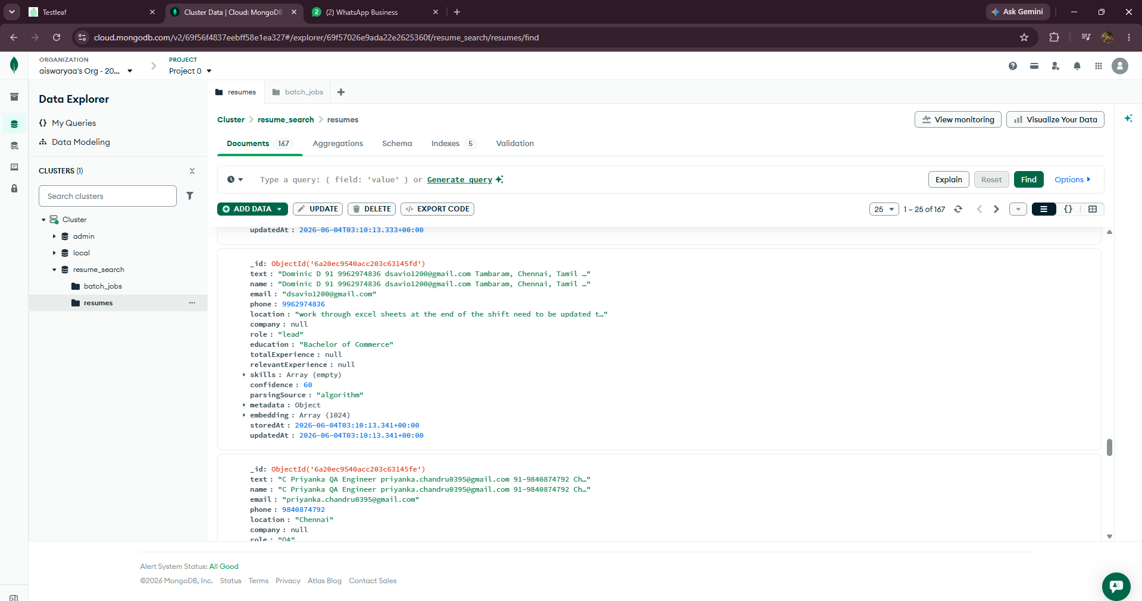

Front End Implementation :

Postman Collection :

1.Upload API
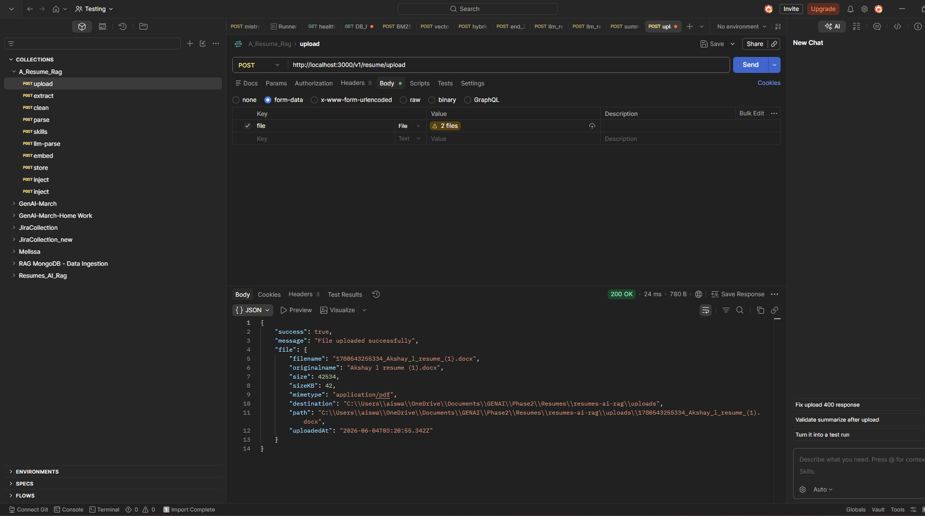

2.Extract :
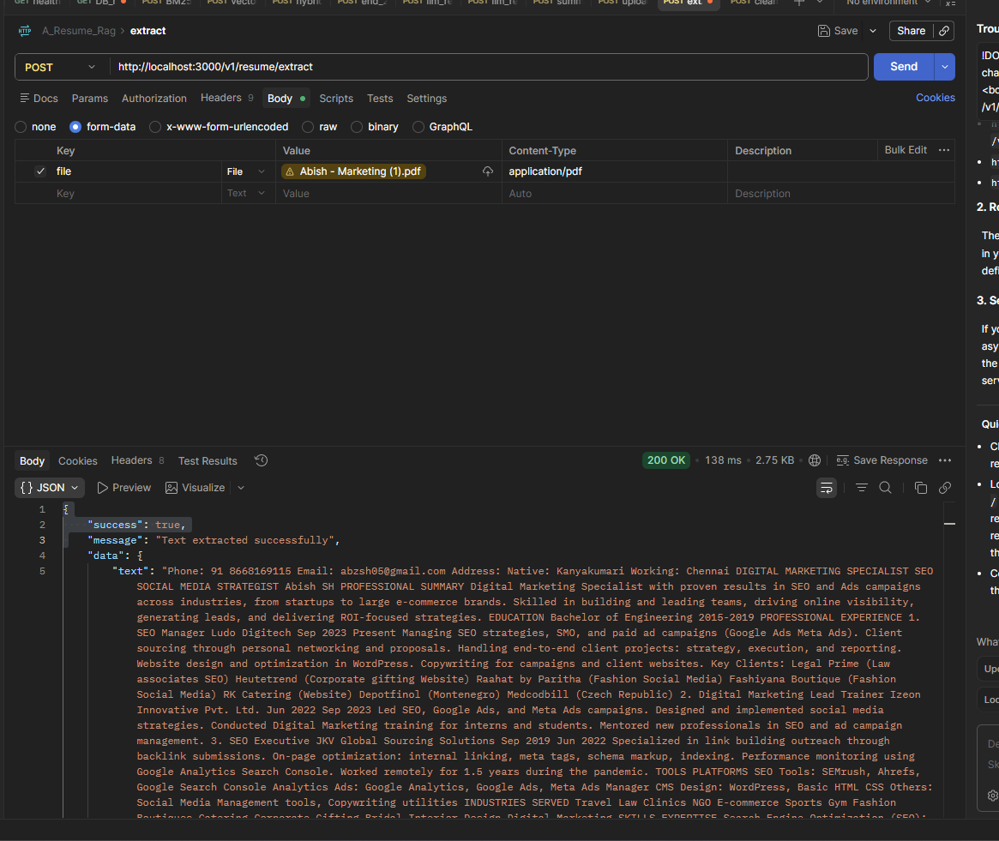
3.Clean
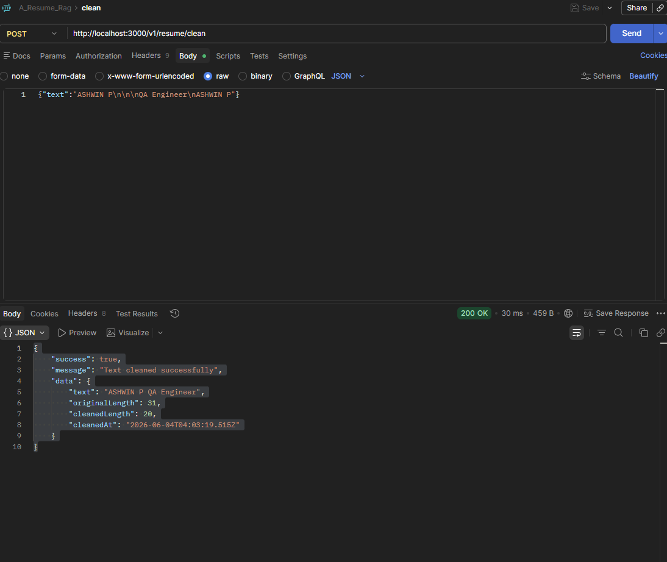
4.Parse:
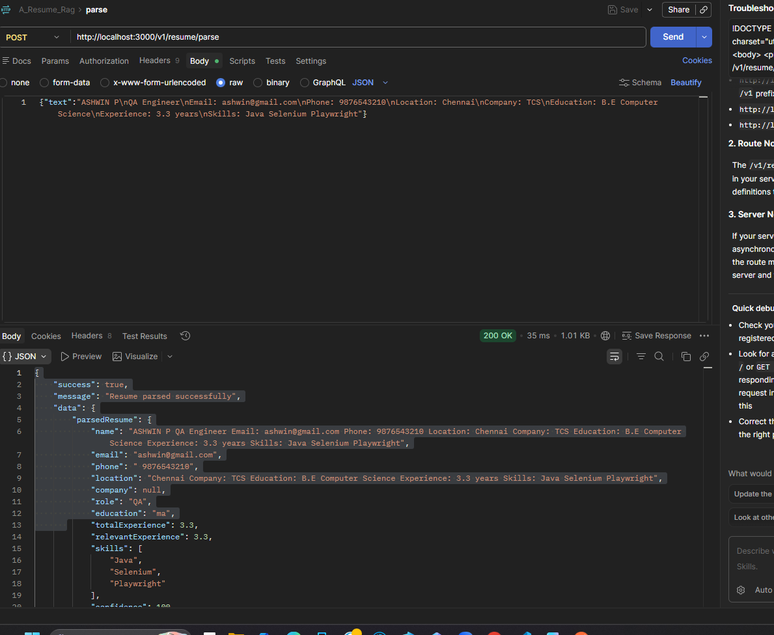
5.Skills :
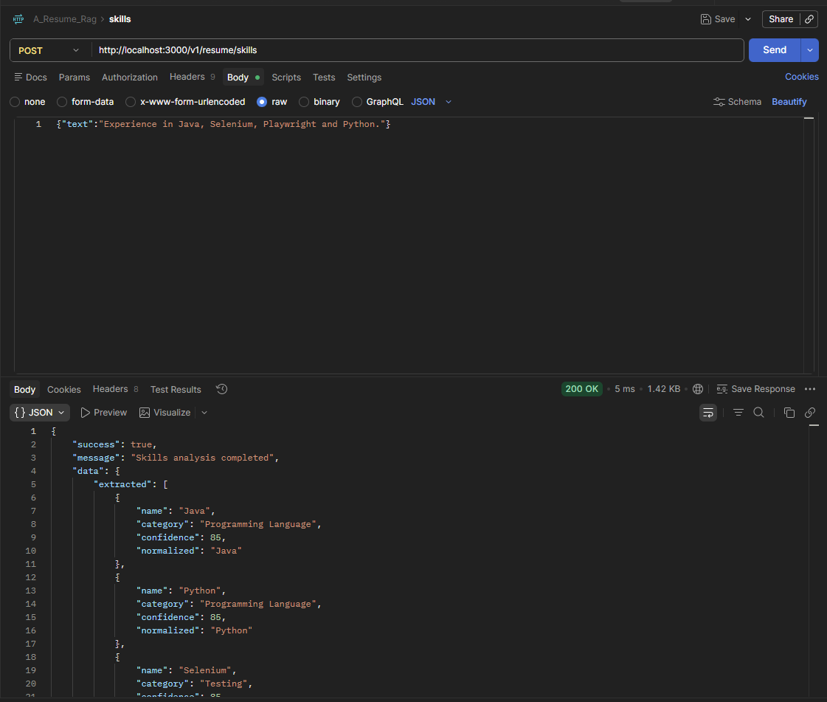
6.LLM Parse
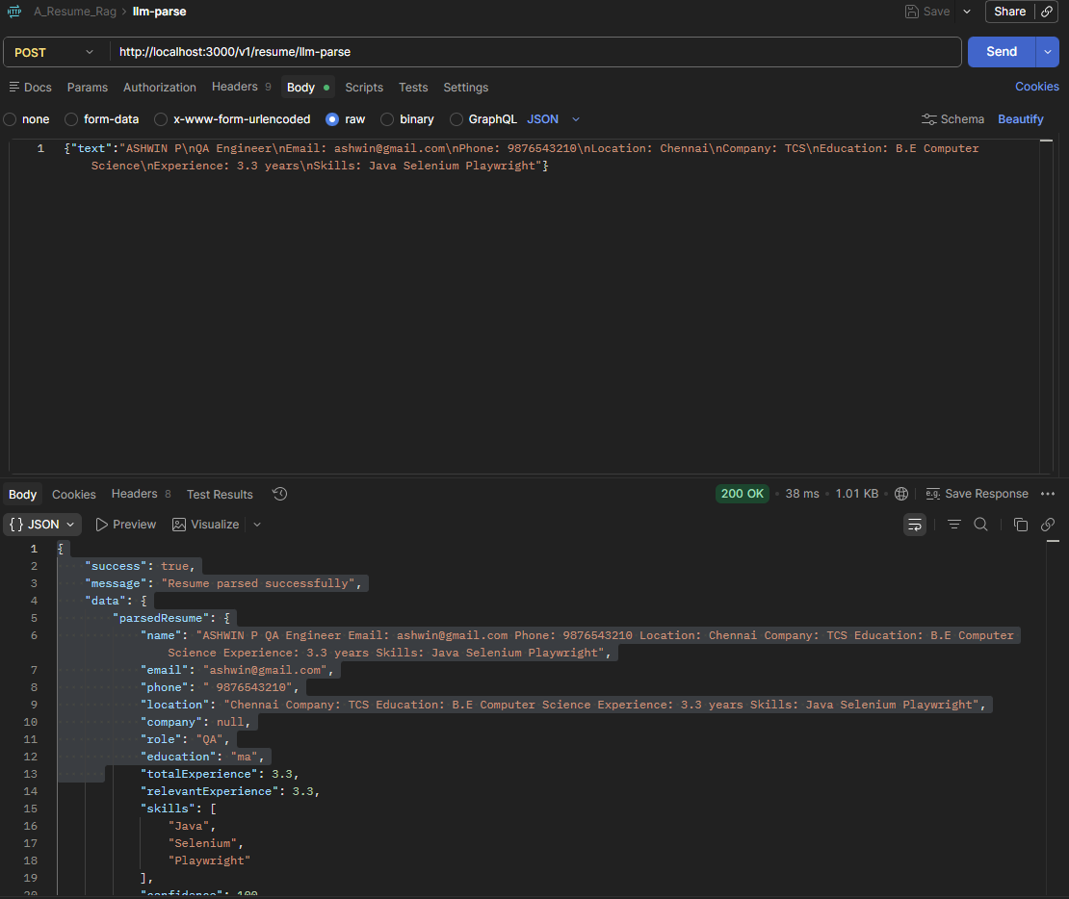
7.Embedding
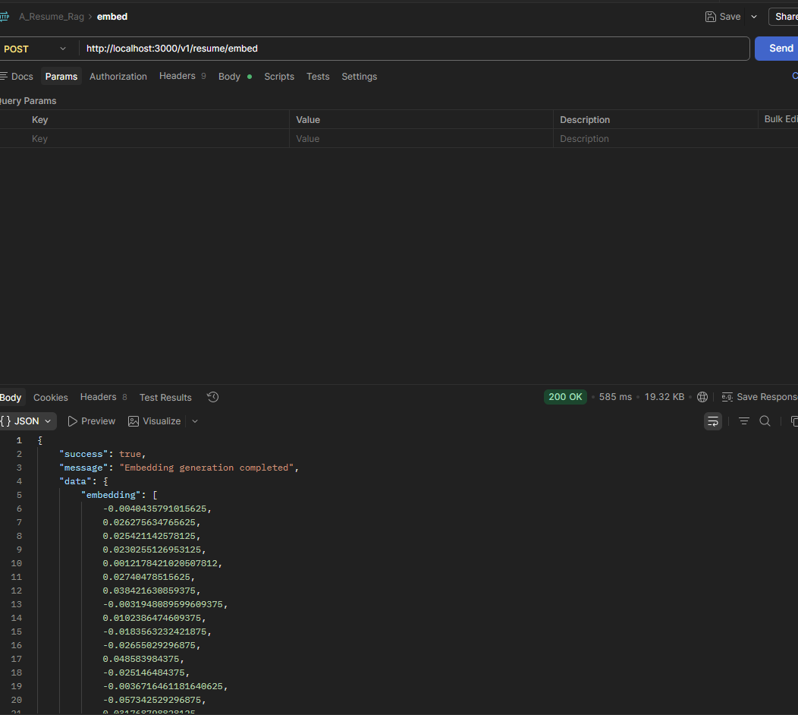
Store
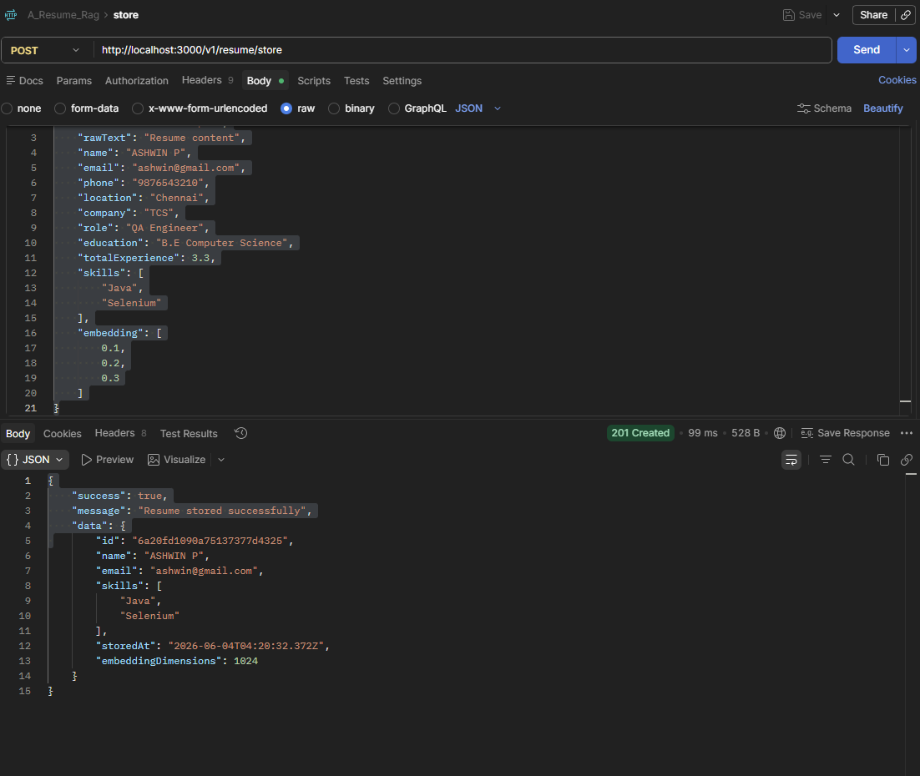
Inject:
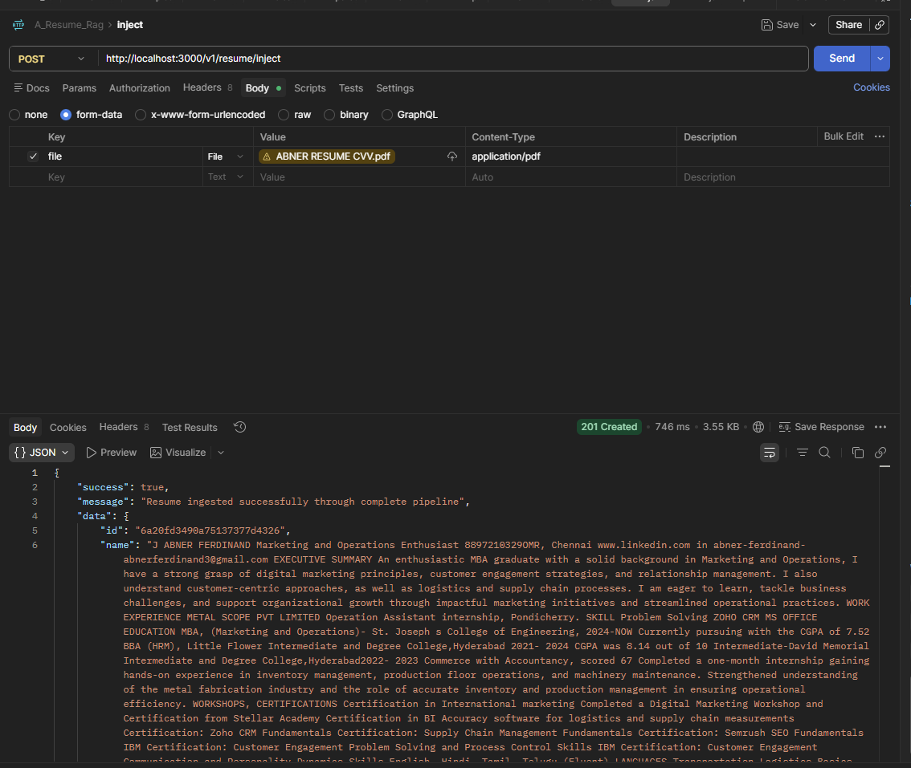

Frontend
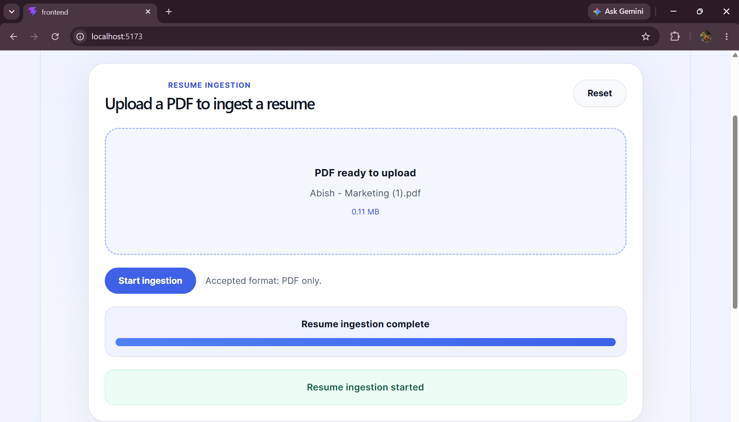

Search : BM25

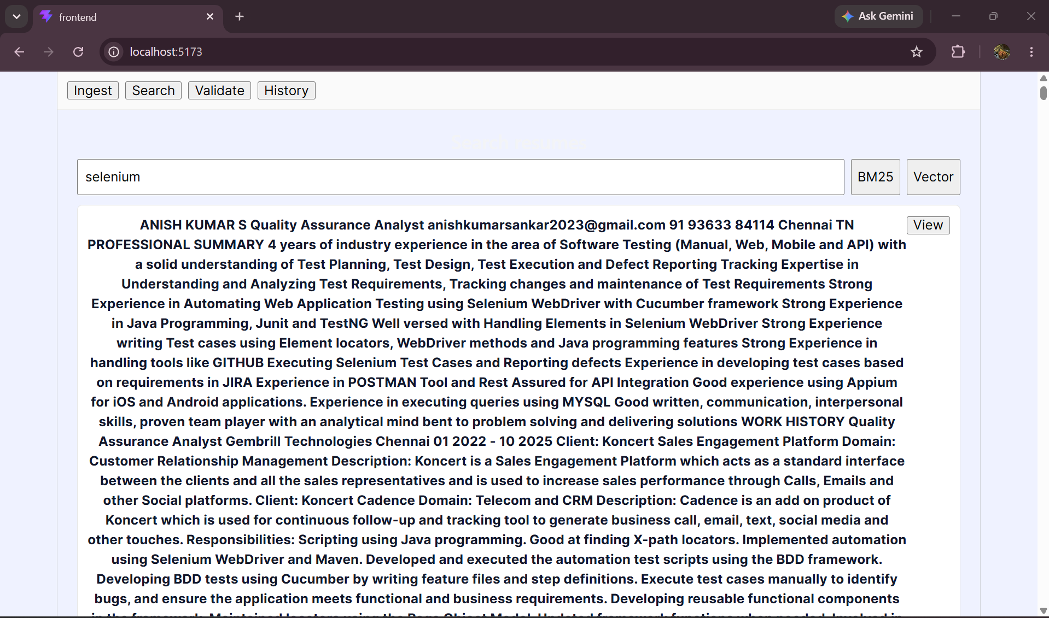

Search Vector :
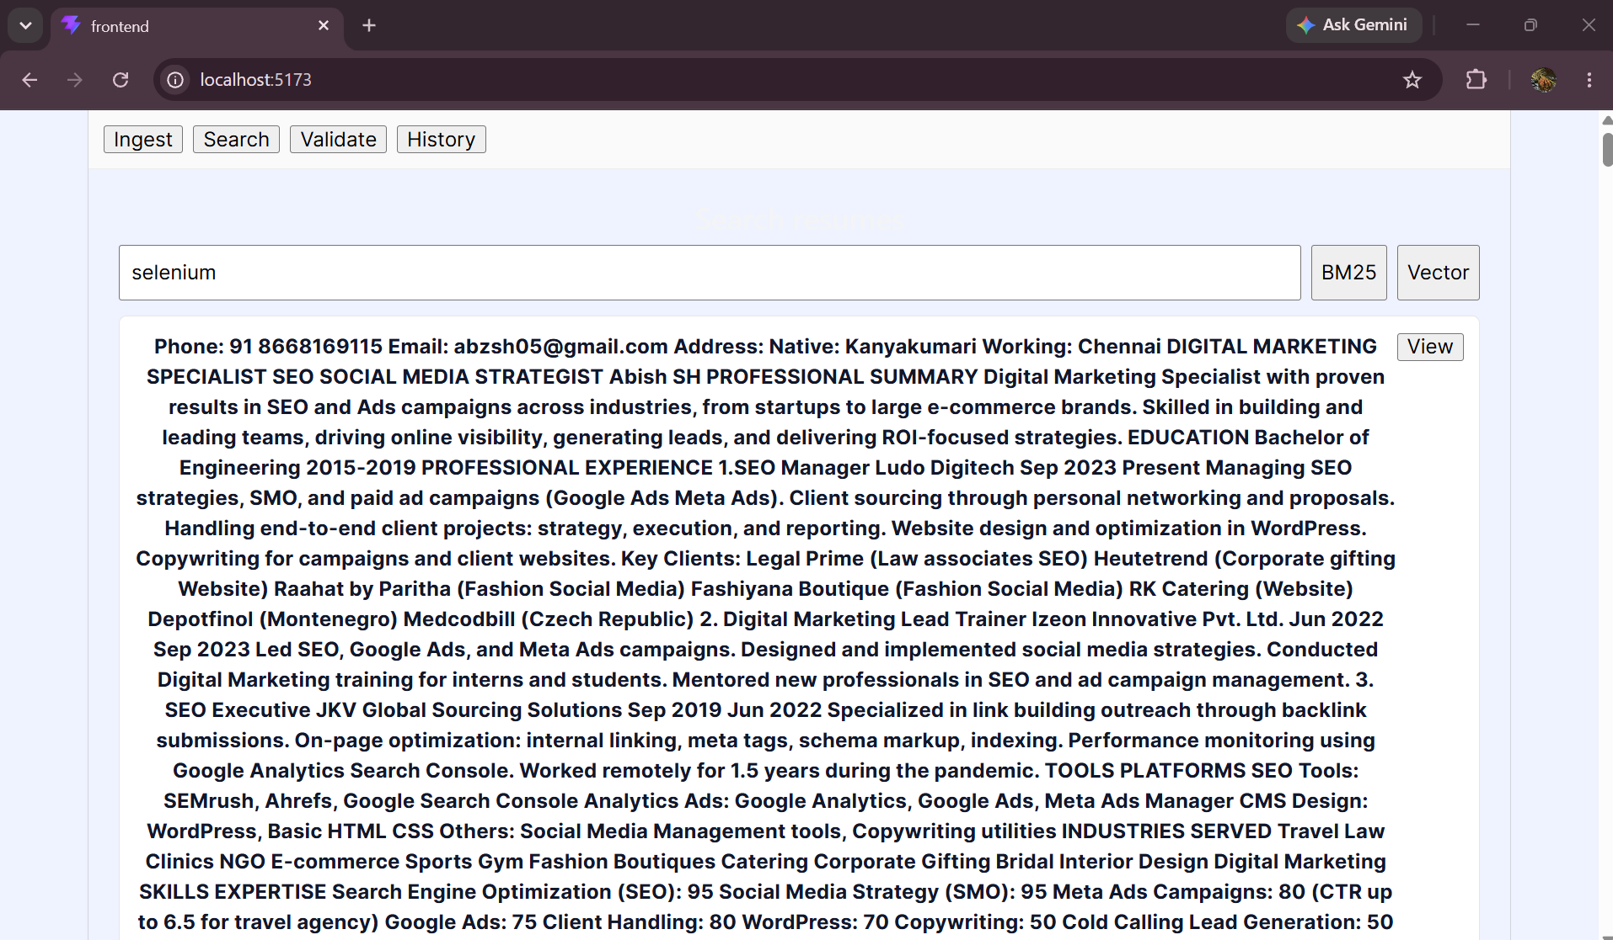
History

